**ACCOUNTING AND TAXATION**

**SUMMER TRAINING UNDERTAKEN AT**

**BREADLAKE ADVISORS PRIVATE LIMITED**

**APAR & CO LLP**

**SUBMITTED IN PARTIAL FULFILMENT OF THE**

**REQUIREMENTSOF BACHELOR OF COMMERCE DEGREE OF**

**BANGALOREUNIVERSITY**

**SUBMITTED BY**

**UNDER THE GUIDANCE OF**

**BATCH OF**

**2021-24**

**STUDENT DECLARATION**

This is to declare that I student of Channasandra Bangalore, batchof 2021-24, has given original data and information to the best of my knowledge in the internship report titled **ACCOUNTING AND TAXATION** undertaken at **APAR & CO LLP** is a record of independent work carried out by me under the guidance and supervision of the faculty of commerce towards the partial fulfilment of requirement for the **BCOM** course.

            I also agree in principle not to share the vital information with any other person outside the organisation and that I have not submitted it for any award or any other title.

**DATE:**                                                   **SIGNATURE OF THESTUDENT**

**PLACE:  Bengaluru**

**ACKNOWLEDGEMENT**

First, I would like to thank Head of**APAR & CO LLP** for giving me the opportunity to do an internship within the organisation.

I would like to express my special thanks of gratitude to our principal sir who gave me the opportunity to do an internship, which helped me in learning a lot of new things and also a warm exposure to the world of accountancy and finance.

It is a great opportunity and pleasure for me to express my profound gratitude towards all the individuals who directly or indirectly contributed towards completion of this report.

Working on this report was a great fun, excitement, challenges and a new exposure in the field of finance. I am greatly debated under whose guidance and concern I am able to bring the report into its real shape.

Although this report has been prepared with utmost care and deep-rooted interest, even then I accept it respondent and imperfect.

I would also like to be thankful to for her support, guidance and constructive feedback.

Lastly, I humbly extend my acknowledgment towards all the efforts of the many individuals who helped me make this internship possible.

My heartfelt thanks to all.

**TABLE OF CONTENTS**

|  |  |  |  |  |
| --- | --- | --- | --- | --- |
|  |  |  | **CONTENTS** | **PAGE**  **NO** |
|  |  |  | **Executive Summary** | **8** |
|  |  |  |  |  |
| **CHAPTERI** |  |  | **INTRODUCTION** | **9-10** |
|  |  |  | Introduction |  |
|  |  |  | Origin of the report |  |
|  | 1.1 |  | Introduction to Chartered Accountant | **11** |
|  |  | 1.1.1 | Countries | **12-14** |
|  |  | 1.1.2 | List of Institutes of Chartered Accountants | **14** |
|  | 1.2 |  | Institutes of Chartered Accountants of India | **15** |
|  |  | 1.2.1 | History of Chartered Accountants | **16-17** |
|  |  | 1.2.2 | Motto of Chartered Accountants | **17** |
|  |  | 1.2.3 | Presidents | **17-22** |
|  | 1.3 |  | Company Profile | **22-24** |
|  | 1.4 |  | Mission of the Company | **24** |
|  | 1.5 |  | Vision of the Company | **25** |
|  | 1.6 |  | Strategies of the Company | **25** |
|  | 1.7 |  | Values of the Company | **25** |
|  | 1.8 |  | Organisational Structure | **25-27** |
|  | 1.9 |  | SWOT Analysis | **28** |
|  | 1.10 |  | Objective of the Study | **29-30** |
|  |  |  |  |  |
| **CHAPTER II** |  |  | **LITERATURE REVIEW** | **31** |
|  | 2.1 |  | Amplification of Auditing | **32-33** |
|  |  | 2.1.1 | Types of Auditing | **33-36** |
|  |  | 2.1.2 | AICPA generally accepted Auditing Standards | **36-37** |
|  |  | 2.1.3 | Professional Conduct | **37-39** |
|  |  | 2.1.4 | Kinds of Audit | **39-42** |
|  |  | 2.1.5 | Audit Risks | **42** |
|  |  | 2.1.6 | Audit Evidence | **43** |
|  | 2.2 |  | Amplification of Income Tax | **44-45** |
|  |  | 2.2.1 | History of Income Tax | **45-46** |
|  |  | 2.2.2 | Agricultural Income | **46-47** |
|  |  | 2.2.3 | Deductions and Due Dates | **47-49** |
|  |  | 2.2.4 | Advance Tax and Amendments due to COVID-19 | **49** |
|  |  | 2.2.5 | Corporate Tax, Surcharges and Penalties | **50** |
|  |  | 2.2.6 | Income Tax Slab Rates | **51-54** |
|  | 2.3 |  | Amplification of Tax Deducted at Source | **55** |
|  |  | 2.3.1 | Objectives of TDS | **55** |
|  |  | 2.3.2 | TDS on Dividends | **55-56** |
|  |  | 2.3.3 | TDS on Immovable property | **56-57** |
|  |  | 2.3.4 | TDS Certificate and Impact of Non-Compliance to TDS | **57-61** |
|  | 2.4 |  | Amplification of Value Added Tax | **61-62** |
|  |  | 2.4.1 | Comparison of VAT with Income Tax and Sales Tax | **62-63** |
|  |  | 2.4.2 | Examples | **64-66** |
|  |  |  |  |  |
| **CHAPTER III** |  |  | **RESEARCH METHODOLOGY AND DATA COLLECTION** | **67** |
|  | 3.1 |  | Research Objectives of the study | **68** |
|  | 3.2 |  | Research Methodology Adopted | **68** |
|  | 3.3 |  | Method of Data Collection | **68** |
|  | 3.4 |  | Analysis technique | **69** |
|  | 3.5 |  | Data Analysis | **69-74** |
|  |  |  |  |  |
| **CHAPTER IV** |  |  | **CONCLUSION** | **75** |
|  | 4.1 |  | Summary | **76** |
|  | 4.2 |  | Evaluation of the work experience | **77** |
|  | 4.3 |  | Recommendations | **77** |
|  | 4.4 |  | Limitations | **78** |
|  | 4.5 |  | Benefits | **79** |
|  |  |  |  |  |
|  |  |  | **REFERENCES** | **80** |
|  |  |  |  |  |

**EXECUTIVE SUMMARY**

**SUMMER INTERNSHIP AT APAR & CO LLP.**

**Introduction**

This summer internship report encapsulates my experiences during the internship at **APAR & CO LLP.** The focused areas were Accounts and Finance, as well as Direct and Indirect Taxation.

In this project, I have studied the firm’s client’s financial statements, analysing theirgrowth, performance and any abnormal losses occurrences, which I observed while assisting the auditor, during the audit of the particular client’s business.

The project also discusses about how charteredaccountant’s firms conducts tax audit of the client’s companies which is statutory in nature.

The primary data has been collected by obtaining the necessary set of books of accounts, financial statements, vouchers, past audit reports etc. from the client’s accounts office. Also, I did a parallel study about the effectiveness of the financial services rendered by the CA firm and why is it necessary for the companies to get the audits done.

In this project, I have also mentioned about the various types of advanced auditing, brief description about the taxation and their usage and necessity along with the analysis and interpretation of the data, gathered through the primary and secondary sources. I also gathered information, views of the clients to examine the effectiveness of the working behaviour and the services provided by the CA firm and the extent of client satisfaction by personally interviewing the staff.

**Conclusion**

My internship at APAR & CO LLP was a valuable learning experience. I express my gratitude to the team for their guidance and mentorship.

**CHAPTER I**

**INTRODUCTION**

**INTRODUCTION**

In today’s world academic education is not adequate to enable a student to compete with confidence and reach his/her goal without having experience with the outside world. In order to have an idea and gain experiences, we, the students of Bachelors of Commerce, RNS FIRST GRADE COLLEGE have to undertake one month internship program at any organization.

As a part of my BCOM Program, the one-month internship program gave me the opportunity to have a practical knowledge on auditing procedure. The assignment was how a chartered accountancy firm performs an audit and also to gain a knowledge and practical experience on how audit work is performed in corporations, companies and non-profit making organizations.

To face much more complex and challenging business world in the challenging business areas, practical knowledge is essential to expand our theoretical base.

This study gave me an opportunity to observe and perform real world knowledge about the audit procedure, which is followed by the chartered accountancy firm. In the internship period I could relate the theoretical knowledge of auditing to practical exposure.

**ORIGIN OF THE REPORT**

The internship program is mandatory requirement for the student who are graduating from the BCOM program under RNS FIRST GRADE COLLEGE of BENGALURU UNIVERSITY.

In the internship program I was engaged in a firm named APAR & CO LLP for one month period. I have learned how an audit is conducted. I also learned about the audit procedures of APAR & CO LLP firm and how the engagement is done in case of an annual audit.

As a result, I have decided to write a report about the audit procedures of APAR & CO LLP from practical knowledge that I have observed.

**1.1 INTRODUCTION TO CHARTERED ACCOUNTANTS**

**Chartered accountants** were the first accountants to form a professional accounting body, initially established in Scotland in 1854. The Edinburgh Society of Accountants (1854), the Glasgow Institute of Accountants and Actuaries (1854) and the Aberdeen Society of Accountants (1867) were each granted a royal charter almost from their inception. The title is an internationally recognised professional designation; the certified public accountant designation is generally equivalent to it. Women were able to become chartered accountants only following the Sex Disqualification (Removal) Act 1919 after which, in 1920, Mary Harris Smith was recognised by the Institute of Chartered Accountants in England and Wales and became the first woman-chartered accountant in the world.

Chartered accountants work in all fields of business and finance, including auditing, taxation, financial and general management. Some are engaged in public practice work; others work in the private sector and some are employed by government bodies.

Chartered accountants' institutes require members to undertake a minimum level of continuing professional development to stay professionally competitive.They provide support to members by offering advisory services, technical helplines and technical libraries. They also offer opportunities for professional networking, career and business development.

Chartered Accountants Worldwide comprises 15 institutes with over 1.8 million Chartered Accountants and students in 190 countries.

**1.1.1 COUNTRIES**

**INDIA**

In India, Chartered Accountants are regulated by the Institute of Chartered Accountants of India(ICAI) which was established by the Chartered Accountants Act, 1949.Associate members of the ICAI are entitled to add the prefix CA to their names. Members who are in full-time practice, and have completed five years of practice, can use Fellow Chartered Accountant (FCA). As of 1 April 2021, the Institute had 327,081 members.

Entry to the profession can be made by taking the CA Foundation course after completion of schooling (12th grade). Alternatively, graduates may train as an articled assistant for three years in a chartered firm before final exam or after completion of Intermediate of Cost Accountant or Company Secretary. A comprehensive 100 hours of information technology training and an orientation programme for soft skills development have to be completed before being articled. However, the CA certification is limited to the geographical boundary of India and is not valid in countries that follow different standards of accounting practice. After clearing of CA final examination, one may apply for membership to ICAI.

**AUSTRALIA**

Chartered accountants of Australia belong to the Chartered Accountants Australia & New Zealand (CA ANZ, formerly the Institute of Chartered Accountants in Australia) and use the designatory letters *CA*. Some senior members (at least 15 years' membership) of the institute may be elected fellows and use the letters *FCA*. Of equal legal status and recognition in Australia as qualified professional accountants are Institute of Public Accountants (IPA) and CPA Australia. On 28 June 2016, the Association of Chartered Certified Accountants (ACCA) and CA ANZ announced a strategic alliance to provide an opportunity for dual membership of both bodies, which will add value for the members locally and globally. ACCA members resident in Australia and New Zealand will be invited to apply for CA membership and CA ANZ members will be invited to apply for ACCA membership, subject to meeting the eligibility criteria of the other body.

**BERMUDA**

The Institute of Chartered Accountants of Bermuda works with the Canadian Institute of Chartered Accountants and American Institute of Certified Public Accountants, and is the sole organisation in Bermuda with the right to award the Chartered Accountant designation.

**CANADA**

In Canada, chartered accountants belong to the Canadian Institute of Chartered Accountants (CICA) by way of membership in at least one provincial or territorial institute (or "order" in Quebec). In order to become a member, a candidate requires an undergraduate degree plus experience and, depending on the province, additional education. Candidates in all provinces are required to pass the three-day Uniform Evaluation (UFE) now Common Final Examination (CFE).

**SOUTH AFRICA**

In South Africa, SAICA, the [South African Institute of Chartered Accountants](https://en.wikipedia.org/wiki/South_African_Institute_of_Chartered_Accountants), regulates the Chartered Accountant (South Africa) designation, CA (SA).

To qualify as a CA (SA), one requires a [specialised bachelor's degree in accounting](https://en.wikipedia.org/wiki/Bachelor_of_Accountancy), followed by a Certificate in the Theory of Accounting (CTA); depending on the university, this is offered as a [postgraduate honours degree](https://en.wikipedia.org/wiki/Bachelor%27s_degree#South_Africa) or as a [postgraduate diploma](https://en.wikipedia.org/wiki/Postgraduate_diploma). This formal education is followed by two external competency exams set by SAICA.

A separate registration is needed for Chartered Accountants wishing to act as auditors in public practice as a registered auditor (RA). The RA designation is conferred by IRBA (Independent Regulatory Board for Auditors, previously known as Public Accountants and Auditors Board [PAAB]) under the Auditing Profession Act (AP Act).

Candidates must complete three years of practical experience, working for a registered training office – the Training in Public Practice (TIPP) programme. Articled clerks who switch employers during this period are required to extend their training by six months. The Training Outside Public Practice (TOPP) programme has a [financial management](https://en.wikipedia.org/wiki/Corporate_finance) focus; TOPP trainees can thus become Chartered Accountants with a more limited knowledge and experience of auditing than those who undergo the TIPP programme, but with a more extensive financial management and business experience.

Chartered accountants who are not registered auditors may not act as or hold out to be auditors in public practice. However, the AP Act does not prohibit non-RAs from using the description 'internal auditor' or 'accountant', or from auditing a not-for-profit club, institution or association if they receive no fee for such audit.

In South Africa the Companies Act was replaced, with effect in July 2010, to allow companies without a public interest to choose between an audit or an independent review. A review is not an attest function and can be performed by accountants who are members of bodies that are registered in terms of the Close Corporations Act of 1984, which include SAIBA, [CIMA](https://en.wikipedia.org/wiki/Chartered_Institute_of_Management_Accountants), SAICA, [SAIPA](https://en.wikipedia.org/wiki/South_African_Institute_of_Professional_Accountants) and [ACCA](https://en.wikipedia.org/wiki/Association_of_Chartered_Certified_Accountants).

**1.1.2 LIST OF INSTITUTES OF CHARTERED ACCOUNTANTS**

* Institute of Chartered Accountants of India
* Institute of Chartered Accountants of Jamaica
* Institute of Chartered Accountants of Namibia
* Institute of Chartered Accountants of Nepal
* Institute of Chartered Accountants of Nigeria
* Institute of Chartered Accountants of Scotland
* Institute of Chartered Accountants of Bermuda
* Institute of Chartered Accountants of England & Wales
* Institute of Chartered Accountants of Eastern Caribbean
* Institute of Chartered Accountants of Barbados
* Institute of Chartered Accountants of Belize
* Institute of Chartered Accountants ofAustralia

**1.2INSTITUTE OF CHARTERED ACCOUNTANTS OF INDIA**

**Emblem of ICAI**

**Institute of Chartered Accountants of India** (**ICAI**) is India's largest professional accounting body under the administrative control of Ministry of Corporate Affairs, Government of India. It was established on 1 July 1949 as a statutory body under the Chartered Accountants Act, 1949 enacted by the Parliament for promotion, development and regulation of the Profession of Chartered Accountancy in India.

In India, Accounting standards and Auditing standards are recommended by the National Financial Reporting Authority (NFRA) to the Government of India which sets the Standards on Auditing (SAs) to be followed in the audit of financial statements in India. The other reputed accounting research bodies in India are Institute of Cost Accountants of India.

The Institute of Chartered Accountants of India was established under the Chartered Accountants Act, 1949 passed by the Parliament of India with the objective of regulating the accountancy profession in India. ICAI is the second largest professional accounting body in the world in terms of number of membership and number of students after the AICPA. It prescribes the qualifications for a Chartered Accountant, conducts the requisite examinations and grants Certificate of Practice.

**1.2.1HISTORY**

The Indian Companies Act, 1913 passed in pre-independent India prescribed various books which had to be maintained by a Company registered under that Act. It also required the appointment of a formal Auditor with prescribed qualifications to audit such records. In order to act as an auditor, a person had to acquire a restricted certificate from the local government upon such conditions as may be prescribed. The holder of a restricted certificate was allowed to practice only within the province of an issue and in the language specified in the restricted certificate. In 1918 a course called Government Diploma in Accountancy was launched in Sydenham College of Commerce and Economics of Bombay. On passing this diploma and completion of three years of articled training under an approved accountant, a person was held eligible for grant of an unrestricted certificate. This certificate entitling the holder to practice as an auditor throughout India. Later on, the issue of restricted certificates was discontinued in the year 1920.

**GOVERNMENT DIPLOMA IN ACCOUNTANCY CERTIFICATE**

In 1930, it was decided that the Government of India should maintain a register called the Register of Accountants. Any person whose name was entered in such register was called a Registered Accountant. Later on, a board called the Indian Accountancy Board was established to advise the Governor General of India on accountancy and the qualifications for auditors. However, it was felt that the accountancy profession was largely unregulated, and this caused much confusion as regards the qualifications of auditors. Hence in the year 1948, just after independence in 1947, an expert committee was created to look into the matter. This expert committee recommended that a separate autonomous association of accountants should be formed to regulate the profession. The Government of India accepted the recommendation and passed the Chartered Accountants Act in 1949 even before India became a republic. Under section 3 of the said Act, ICAI is established as a body corporate with perpetual succession and a common seal.

**1.2.2MOTTO**

The motto of the ICAI is Ya Aeshu Suptaeshu Jagruti, which literally means "a person who is awake in those that sleep". It is a quotation from the Upanishads. It was given to the ICAI at the time of its formation in 1949 by Sri Aurobindo as a part of its emblem. CA. C. S. Shastri, a Chartered Accountant from Chennai went to Sri Aurobindo and requested him through a letter to give an emblem to the newly formed Institute of which he was an elected member from the Southern India. In reply to this request, Sri Aurobindo gave him the emblem with a Garuda, the mythical eagle in the centre and a quotation from the Upanishad: Ya Aeshu Suptaeshu Jagruti. The emblem along with the motto was placed at the first meeting of the Council of the Institute and was accepted amongst many other emblems placed by other members of the council.



**NEW CA LOGO FOR EXCLUSIVE USE BY CHARTERED ACCOUNTANTS**

Apart from its emblem, ICAI also has a separate logo for its members. As a part of a brand building exercise, ICAI introduced this separate new CA logo for the use of its members in 2007. The logo is free for use by all members of ICAI subject to certain conditions. The logo was launched by the then Minister of Corporate Affairs, Prem Chand Gupta at the occasion of the Chartered Accountant Day in the presence of the then President of ICAI Sunil Talati. Members of ICAI cannot use the ICAI emblem, but they are encouraged to use the CA logo instead on their official stationery.

**1.2.3 PRESIDENTS**

ICAI's first president was Mr. G.P. Kapadia (1949 to 1952). CA. Ranjeet Kumar Agarwal is the current president.

**ROLE OF CHARTERED ACCOUNTANTS**

Chartered accountants work in all fields of business and finance, including auditing, taxation, financial and general management. Some are engaged in public practice work; others work in the private sector and some are employed by government bodies.

**WHO IS A CHARTERED ACCOUNTANT?**

A chartered accountant is an internationally recognised financial professional who manages budgets, auditing, taxes and business strategies for clients. As a CA, you can work for businesses, the government and individuals. Your job is to provide expert financial advice and help clients manage their funds. The chartered accountant credential qualifies an individual to offer financial consultation and keep financial records.

**WHAT DOES A CHARTERED ACCOUNTANT DO?**

You can work in many different sectors, but you are likely to perform a similar set of duties whatever the industry vertical. Here is a list of critical responsibilities of chartered accountants:

**Accounting And Auditing**

From basic bookkeeping to complex financial analysis, accounting is one of your responsibilities. Additionally, you may also work on audits. Given your CA expertise, auditing is one of the most valuable services you provide. When you run an audit, you go through the accounts within financial statements presented to your clients. You check that they are based on the proper accounting guidelines and represent the actual state of the funds belonging to this client. Auditing is entrusted to CAs because this requires your specialised education, training, judgement and financial skills.

**Management Consultancy**

Chartered accountants are often asked to serve in a consultative role, helping businesses utilise resources efficiently. As a management consultant, you can provide consulting services like:

* Designing, developing and implementing systems for budgetary control and cost accounting, and computer programs for accounting and commercial activities.
* Developing Management Information Systems (MIS) and Accounting Information Systems (AIS).
* Consulting on complicated financial matters like international tax laws, collaborations and mergers, along with corporate law.
* Evaluating the prospects of new business ventures like expansion, project launches and amalgamations.
* Advising management teams on practical organisational skills, such as delegation strategies and planning of work.
* Analysing existing systems for operational control, financial planning and resource utilisation and suggesting improvements.
* Taking responsibility for the effective use of business capital and making sure that working capital has an effective return in terms of productivity.
* Helping with decisions on matters like product ranges and pricing.
* Assisting in interactions with government bodies.
* Serving as registrars on matters of share transfers and other securities.

**Tax Management**

Businesses, individual clients and other institutions often need a chartered accountant's extensive knowledge and expertise when dealing with taxation. As a CA, you have extensive training on the various statutory taxes. Your clients need the services of someone who has a clear understanding of current tax information.

Tax assessment is an integral part of finance management. Chartered accountants help clients file their tax returns, represent their clients in interactions with income tax authorities and generally provide advice on all tax-related matters.

**Cost Accountancy**

As a CA, your training means that you can offer professional advice to companies on matters related to production. Whether the company provides a product or a service, your guidance can help them calculate the production costs accurately during various stages of operation. You can guide the management team with cost control strategies and the right selling price for their products or services.

**Settlements and estates**

You might serve as executor of a will or trust to administrate a settlement or an estate. In a role like this, you may work closely with a solicitor or lawyer. Sometimes, a solicitor or lawyer working on trust or estate settlements might bring you in to assist with the accounting side of the work.

**Serving on Board of Directors**

Most companies understand and value the advantages of having a chartered accountant occupy a seat on their board of directors. CAs with years of experience are often chosen for this role. Once you have built some experience in senior positions within the industry, you could be asked to serve as the director of a company.

**Serving as secretary of an organisation**

Well-structured companies may prefer to hire a CA in the role of secretary among the management. Often, groups of companies may also choose to appoint you in a secretarial role. Your main responsibility is to assist the board of directors in areas like finance, administration, accounting, and taxation.

**Arbitration duties**

You may also play the part of an arbitrator in issues of dispute settlement. For example, if a business fails and declares bankruptcy, you can help prepare statements of affairs. You can also serve as a company's trustee in case of bankruptcy or under a deed of arrangement.

**Investigative duties**

Your expertise can be a valuable asset to companies that want a clear picture of their financial position. For instance, companies may want to perform investigative duties when:

* Selling a business
* Acquiring a business
* Finding new financial opportunities for a business

Companies may also hire you to boost efficiency within management or analyse why profits are up or down.

**How do Chartered Accountants contribute to business development?**

Chartered Accountants play consultative and strategic roles, providing financial insights, assisting in decision-making, and managing risks.

Chartered Accountants are highly trained, ethical, and regulated professionals with a vast range of responsibilities essential for the smooth financial operation and growth of businesses.

Their extensive education and rigorous professional examination process ensure they are well-equipped to handle various financial tasks, from auditing to tax consulting and strategic financial advice.

They operate under the guidance of professional bodies that maintain high ethical standards and continue to promote professional development. Their specialized knowledge can also be focused in areas such as forensic accounting or tax consulting.

Chartered Accountants are not just number crunchers but key strategic advisors who significantly contribute to business development by providing critical insights, identifying growth opportunities, and managing risks.

Their integrity, objectivity, and professional competence play a crucial role in maintaining public trust in the accounting profession.

**REGULATIONS**

Rules made by the Central Government.

**The Chartered Accountants Act & Regulations**

**For Membership**

* Enrolment as Member
* Grant of Certificate of Practice
* Payment of Membership fees
* Removal of Name
* Restoration of Name
* Training of Articled Assistant
* Issue of Duplicate Certificate
* Change in the Name of Members
* Change in Professional Address

**For Firm**

* Approval of Trade/Firm Name
* Registration of Firm
* Maintenance of Brand Office
* Change in Constitution of Firm
* Revised Guidelines of Network
* Practice in Corporate Form
* Rules of Merger-Demerger

**1.3 COMPANY PROFILE**

**NAME OF THEEMPLOYER: Mr. Amruth Lal Ratanshi Patel**

**ADDRESS: No.4 (Old no.9), 1st Floor, 15th Cross 100 Feet Ring Road, Sarakki NA**

**JP Nagar Bangalore Karnataka 560078**

**EMAIL:** [**caamruthlalrpatel@gmail.com**](mailto:caamruthlalrpatel@gmail.com)

**A Chartered Accountant**is useful for growing the economy of the country. With deep knowledge in the stock market, Forex, law matters and finance taxation every chartered accountant has knowledge different from each other. They make every person in understanding the rules and guidelines. “CAs in India are technically far superior but accounting now is not just about technicality. It is also about identifying and solving problems. Clients look and value those CAs who can be trusted as advisors and who understand the dynamics business”.

The market requires a CA who has the specialization in equity, IPO, insolvency, merging of companies’ acquisition analysis. It includes advising, strategies, audit to the business, CA has to understand the reports and changing the business scenarios. The audit and accounting concerns with the protection of data from cyber frauds. The globalisation is also the major reason why CA is mandatory for the companies.

The change in Economy is also a challenge for the **professional Chartered accountants** as to keep the detailed knowledge of the changes occurring, their consequences and the measures which could be taken to overcome the difficulties which could come in the way as a result of the challenges.

APAR & CO LLP (liability limited partnership) firm is a One Stop Shop Solutions for all your Financial, Accounting, Taxation and Investment needs. At APAR & CO LLP we have a Very Qualified Team of Experienced Chartered Accountants and Cost Accountants. It was established in the year 2020. It is a chartered accountancy firm rendering comprehensive professional services which include audit, management consultancy, tax consultancy, accounting services etc.

They are registered with the ICAI and are eligible to offer following Chartered Accountant services:

* Accounting Services
* Auditing Services
* Income Tax Services
* Societies and Trust Consultancy
* Sales Tax matters Consultancy
* Service Tax matters Consultancy

**Accounting Services**

They offer highly efficient accounting services which are provided by them for their clients. They also offer design, implementation and review of accounting manual. Their accounting services are offered at market leading rates.

* Design, implementation and review of accounting manual.
* Advice on various accounting issues including those related to Indian GAAPs.

**Auditing & Assurance Services**

They are blessed with team of qualified chartered accountants highly efficient in auditing and assurance services. Their wide range of services are aimed for financial stability of the clients and take care of the decision-making abilities. The services they provide are in compliance with the legal environment.

* Statutory audit
* Company Audit
* Internal Audit
* Tax Audit

**Income Tax Services**

They specialize in providing Income tax services to individuals, small scale and medium scale businesses which are highly effective and efficient. Our range of services include preparation of returns, getting assessment done, TDS and withholding tax compliance, fringe benefit tax compliance and income tax appeals before CIT and ITAT.

* Preparation of return
* Getting Assessment done
* Consultancy in tax matters & tax planning
* TDS & Withholding tax compliance
* Income Tax Appeals before CIT (Appeals)
* Income Tax Appeals before ITAT

**Societies And Trust Audit**

They are engaged in providing auditing services to societies and trust consultancy to their clients.

**Service Tax Matters Consultancy**

They have rich experience in offering service tax matters consultancy which are vital in the current scenario. Our range of services include filing of returns, maintenance of records and They also properly assess the situation of our clients. The consultancy is provided by them at market leading rates.

* Registration
* Filing of return
* Maintenance of Records
* Assessment
  1. **MISSION OF THE COMPANY**

APAR & CO LLP’s mission is to provide complete, reliable and high-quality auditing, accounting and consulting services to institutions, be it manufacturing, trading, tourism, financial, governmental, non- governmental, medical, hydro power, information technology and any other sectors. The firm exists to deliver the services in a timely, efficient and innovative manner to serve the best interest of the client.

* 1. **VISION OF THE COMPANY**

The firm's vision is to be the most respected and trusted professional auditing firm in Bengaluru, where clients come with a belief that their problems would be solved in an efficient manner.

* 1. **STRATEGIES OF THE COMPANY**

The firm focuses on providing the best quality service to their clients. The firm’s plan is to reach out to as many businesses of all sector and provide them with high quality and fast service. To achieve this the firm has built a strategy to attract newer qualified certifies CA, article trainees and CA articles. The firm makes sure that the services they provide to their client meet the client’s expectation and their standards.

* 1. **VALUES OF THE COMPANY**

The values of the APAR & CO LLP are as following:

* **Build strong relation with client**

APAR & CO LLP believes that our success depends primarily on building a strong relation with clients. The firm focuses on earning a long-term client loyalty and trust by developing a deep understanding of client’s business and goals. To build strong and long-term relation with client. The firm provide timely, effective and quality services to the clients according to their requirement.

* **Upholding Quality and Integrity**

The firm’s main target is to provide high quality service to each client. The firm focuses on maintaining an environment of honesty, fairness and respect within the firm and with clients and society. The firm promises to follow professional ethics and rules while conducting services.

* 1. **ORGANIZATIONAL STRUCTURE**

The firm has a hierarchy organization structure. On the top of the hierarchy pyramid stays the two main partners. CA Amruth Lal Ratanshi Pateland CA Ashwin Patel, are the two main partner of firm who are Fellow Chartered Accountants and registered as “A” class auditors holding certificate of practice. A senior manager falls below the partners. Below the senior manager lies three other managers. The three managers are Nayan, Mahesh and Kousalya.

All the clients of the firm are distributed among the three managers. This ensures that the workload is distributed among the three managers and no single manager is overburdened with work. This helps in providing personalized services to firm’s clients as each of the three managers can focus on the specific needs of their assigned clients.

As the firm has hierarchy structure the decision is made by the senior level staff, which has to be followed by the junior level staff.The responsibility to hire new article ship, article trainees and interns is given to the manager. Similarly, the responsibility to hire new manager is given to the senior partner and senior manager.

**DIAGRAM OF THE ORGANISATIONAL STRUCTURE**

**SENIOR PATRNERS**

**MANAGERS**

**ARTICLESHIP, ARTICLE TRAINEES AND INTERNS**

**MY JOB POSITION**

In APAR & CO LLP, my job position was as an intern. In the firm there is no department and division separated. Instead, has three managers who oversee article ship, article trainees and intern’s work. During this internship program, I worked under one of the managers and gain practical experience working with a team of other article ship and article trainees. I was assigned to clients under his supervision with the team of other article ship and article trainees.

**My Job Position in the Organizational Structure**

My job position in the organisational structure is highlighted in red colour in the diagram below:

**SENIOR PARTNERS**

**MANAGERS**

**ARTICLESHIP, ARTICLE TRAINEES AND INTERNS**

* 1. **SWOT ANALYSISOF APAR & CO LLP**

**STRENGTH**

* The senior partners have a strong bond with reputed and well-known company.
* Friendly working environment.
* Maintaining good relation with client.
* Provide quality and fast service according to client’s requirement.
* Have clients base of different sectors.
* Have motivated and skilled human resource.

**WEAKNESS**

* Insufficient article ship and article trainees.
* Lack of training session to staffs.
* Communication barrier between the bottom-level to top-level management.
* Lack of retention of staff.

**OPPORTUNITIES**

* When more amount of business starts to grow in the country more client opportunity develops for the firm.
* More CA and ACCA graduates in Bengaluru.
* Implementation of new accounting standards and relevant regulation.

**THREATS**

* Establishment of newer audit firm.
* Limited number of CA are only pass in Bengaluru.
* Higher remuneration in corporate sector.
* Certifies CA and ACCA go to other country for job.
* Decline in the number of new business establishment, which would affect the firm client base.
  1. **OBJECTIVE OF THE STUDY**

Studying from books and getting good grades only does not define success. For success, one must gain practical exposure and be able to use that academic knowledge in real world. One of the platforms, which provides individual to get practical exposure and apply the knowledge and skill in real world, is through the internship program. The internship program provides opportunity to an individual to see how the real business world functions.

I choose to work with APAR & CO LLP. During this internship I have learnt many new skills. Before internship I had only theoretical knowledge about work in the organisation, now I have some practical experience of working in the organisation’s environment and how organisations work and achieve their goals and objectives.

This internship has given me the understanding of business and also about the elements of strategic thinking, planning and implementation, and how these things are applied in a real-world organisation environment.

**My other sub-objective is as following:**

1. Gain practical experience in accounting and auditing.
2. Develop professional skills such as communication, teamwork, time management, and problem solving.
3. Understand the importance of ethics and professionalism in the accounting profession.
4. Build a professional network that can be useful in finding job opportunities and advancing my career in the future.
5. Understanding regulatory environment in which the CA firm operates, including the applicable accounting and auditing standards, taxation laws, and other regulations.
6. Opportunities to work with clients from different industries and sectors, thereby providing a broad exposure to the corporate world.
7. Improve communication skills.
8. Analyse the business situation.
9. Establish high standards on professionalism.
10. Learn more than the theoretical knowledge.
11. To learn book keeping practices of different companies.
12. To apply the theoretical knowledge in actual organisation.
13. To compare practical aspects with theoretical aspects.
14. To make quick decision in real situation.
15. To learn how to promote and to conduct research inbusiness area.
16. To promote my personal knowledge and professional preparation for future. To properly integrate my theoretical knowledge and practical work.
17. To plan for the future of oneself and learn how to adjust in an organisation.
18. To know how to present your recommendations in front of your boss.
19. To get knowledge of opportunities and threats while entering into an organisation.
20. To get exposure to do a work in an organisation and also known about organisational behaviour, ethical rules andregulations.

**CHAPTER II**

**LITERATURE REVIEW**

**2.1 AMPLIFICATION OFAUDITING**

**DEFINITION OF AUDITING**

Arens and Loebbecke, 1998 defines Auditing as:

**“**Auditing is the process by which a competent, independent person accumulates and evaluates evidence about quantifiable information related to a specific economic entity for the purpose of determining and reporting on the degree of correspondence between the quantifiable information and established criteria**.”**

This definition includes several key words and phrases. To understand the definition, different terms are discussed below:

* **Competent, Independent Person**

The auditor must be qualified to understand the criteria used and competent to know the types and amount of evidence to accumulate to reach the proper conclusion after the evidence has been examined. The auditor must also have an independent mental attitude. It does little good to have a competent person who is biased performing the evidence accumulation when unbiased information and objective thinking are needed for the judgments and decisions to be made. Independence cannot be absolute by any means, but it must be a goal that is worked toward; and it can be achieved to a certain degree.

* **Accumulating and Evaluating Evidence**

Evidence is defined as any information used by the auditor to determine whether the quantifiable information being audited is stated in accordance with the established criteria. Evidence takes many different forms, including oral testimony of the auditee (client), written communication with outsiders, and observation by the auditor. It is important to obtain sufficient quality and volume of evidence to satisfy the audit objectives. The process of determining the amount of evidence necessary and evaluating whether the quantifiable information corresponds to the established criteria is a critical task for every auditor.

* **Quantifiable Information and Established Criteria**

To do an audit, there must be information in a verifiable form and some standards (criteria) by which the auditor can evaluate the information. Quantifiable information can and does take many forms. It is possible to audit such thing as a company’s financial statements, the amount of time it takes an employee to complete an assigned task, the total cost of a government construction contract, and an individual’s tax return. The criteria for evaluating quantitative information can also vary considerably. For example, in auditing a vendor’s invoice for the acquisition of raw materials, it is possible to determine whether materials of the quantity and stated description were actually received, whether the proper raw material was acquired considering the production needs of the company, or whether the price charged for the goods was reasonable. The criteria used depend upon the objectives of the audit.

* **Economic Entity**

Whenever an audit is conducted, the scope of the auditor’s responsibility must be made clear. The primary method involves defining the economic entity and the time period. In most instances the economic entity is also a legal entity, such as a corporation, unit of government, partnership, or proprietorship. In some cases, however, the entity is defined as a division, a department, or even an individual. The time period for conducting an audit is typically one year, but there are also audits for a month, a quarter, several years, and in some cases the lifetime of an entity.

* **Reporting**

The final stage in the audit process is the audit report the communication of the findings to users. Reports differ in nature, but in all cases, they must inform readers of the degree of correspondence between quantifiable information and established criteria.

**2.1.1 TYPES OF AUDITING**

There are various types of audits. Such as:

* Operational Audit
* Compliance Audit
* Audit of Financial Statements
* Internal Audit
* Interim Audit
* Performance Audit
* Governmental Audit

1. **Operational Audit**

Operational Audit refers to the study of business operations for the purpose of making recommendations about the economic and efficient use of resources, effective achievement of business objectives and compliance with company policies. At the completion of an operational audit, recommendations to management for improving operations are normally expected. The goal of operational audit is to help managers to discharge their management responsibilities and improve profitability.

1. **Compliance Audit**

Management often wants to know whether its organizational policies are being complied with or whether external mandates are being met. The purpose of a compliance audit is to determine whether the auditee is following specific procedures or rules set down by some higher authority. Results of compliance audits are generally reported to someone within the organizational unit being audited rather than to a broad spectrum of users. Management, as opposed to outside users, is the primary group concern with the extent of compliance with certain prescribed procedures and regulations. Hence a significant portion of work of this type is done by auditors employed by the organizational units themselves.

**Compliance audit involves:**

1. Examining transactions and detailed records, and
2. Identifying weaknesses.
3. **Audit of Financial Statements**

Financial statements audits are conducted to determine whether financial statements are presented fairly in accordance with generally accepted accounting principles (GAAP). However, public sector financial audits also determine whether financial statements are presented in accordance with applicable laws and regulations. An audit of financial statements is conducted to determine whether the overall financial statements – the quantifiable information being verified – are stated in accordance with specific criteria. The financial statements most commonly included are the statement of financial position, income statement and statement of cash flow, including accompanying footnotes. The assumption underlying an audit of financial statements is that they will be used by different groups for different purposes. Therefore, it is more efficient to have one auditor perform an audit and draw conclusion that can be relied upon by all users than to have each user perform his or her own audit.

1. **Internal Audit**

Internal audit is an independent appraisal function established within an organization to examine and evaluate its activities as a service to the organization. The objective of internal auditing is to assist members of the organization in the effective discharge of their responsibilities. To this end, internal audit furnishes them with analyses, appraisals, recommendations, counsel, and information concerning the activities reviewed. Internal audit is practiced by auditors employed by an organization, such as a bank, hospital, city government, or industrial company. The Institute of Internal Auditors is the international organization that governs the standards, continuing education, and general rules of conduct for internal auditors as a profession.

1. **Interim Audit**

Interim audit refers to the procedures applied prior to the client’s year end, primarily for the purpose of lowering the assessed risk level. The interim audit phase consists of resting the client’s internal accounting controls and performing substantive tests of transactions. Interim audit procedures performed several weeks or months before the balance sheet date. In recent years, certain changes in the information processing environment have begun to alter the traditional approach to the interim audit. Instead of testing the internal control procedures during a single interim time period, auditors are applying these tests, along with tests of selected transactions, at frequent intervals throughout the year. This sometimes referred to as Continuous Audit. This type of audit is especially applicable to those clients with sophisticated computer-based accounting applications.

1. **Performance Audit**

Performance audits address the economy, efficiency, and program results of a reporting unit. Economy and efficiency audits are performed to determine whether management’s objectives are being achieved and to identify opportunities and develop recommendations for improvements. Program audit includes determining:

1. the extent to which the desired results or benefits established by the legislature or other organizing body are being achieved,
2. the effectiveness of organizations, programs, activities, or functions, and
3. whether the entity has complied with laws and regulations applicable to the program.

**g)Governmental Audit**

Governmental audit may be defined as testing and reporting on conformity with laws and regulations relating to recipients of federal financial assistance. Governmental audit refers to the independent auditor’s responsibility for determining compliance with laws and regulations when engaged in audits of state and local governmental units, as well as other not-for-profit entities, that are the recipients of federal finance assistance.

Governmental auditors are employed by various state, local, and federal agencies. The work performed by these auditors’ ranges from an internal audits of a specific agency to audits of other governmental units to audits of reports furnished to the government by outside organizations.

**2.1.2 AICPA GENERALLY ACCEPTED AUDITING STANDARDS**

Auditing standards are general guidelines to aid auditors in fulfilling their professional responsibilities in the audit of historical financial statements. They include consideration of professional qualities such as competence and independence, reporting requirements, and evidence.

The broadest guidelines available are the ten Generally Accepted Auditing Standards (GAAS). These standards were developed by the AICPA in 1947, they have, with minimal changes, remained the same. These standards are not sufficiently specific to provide any meaningful guide to practitioners, but they do represent a framework upon which the AICPA can provide interpretations.

The ten Generally Accepted Auditing Standards are as follows:

**General Standards**

1. The audit is to be performed by a person or persons having adequate technical training and proficiency as an auditor.
2. In all matters relating to the assignment, independence in mental attitude is to be maintained by the auditor or auditors.
3. Due professional care is to be exercised in the performance of the audit and the preparation of the report.

**Field Work Standards**

1. The work is to be adequately planned, and assistants, if any, are to be properly supervised.
2. A sufficient Understanding of the internal control structure is to be obtained to plan the audit and to determine the nature, timing, and extent of tests to be performed.
3. Sufficient competent evidential matter is to be obtained through inspection, observations, inquiries, and confirmations to afford a reasonable basis for an opinion regarding the financial statements under audit.

**Reporting Standards**

1. The report shall state whether the financial statements are presented in accordance with generally accepted accounting principles (GAAP).
2. The report shall identify those circumstances in which such principles have not been consistently observed in the current period in relation to the preceding period.
3. Informative disclosures in the financial statements are to be regarded as reasonably adequate unless otherwise stated in the report.
4. The report shall either contain an expression of opinion regarding the financial statements, taken as a whole, or an assertion to the effect that an opinion cannot be expressed. When an overall opinion cannot be expressed, the reasons therefore should be stated. In all cases where an auditor’s name is associated with financial statements, the report should contain a clear-cut indication of the character of the auditor’s work, if any, and the degree of responsibility the auditor is taking.

**2.1.3 PROFESSIONAL CONDUCT**

The AICPA Code of Professional Conduct (the Code) consists of four components. The principles provide the ethical concepts on which the Rules of Conduct are based as well as the standards for meeting the public trust. The principles provide the broadest framework for professional conduct and should be the highest guide for professional action. Auditors should always look first to the principles for professional guidance. The rules are only guides to help accomplish the broad principles of the profession.

**AICPA Code of Professional Conduct**

**Concepts**

Ideal standards of ethical conduct stated in philosophical terms. They are not enforceable.

**Rules of Conduct**

Minimum standards of ethical conduct stated as specific rules. They are enforceable.

**Interpretations**

Interpretations of rules of conduct by the AICPA Division of Professional Ethics. They are not enforceable, but a practitioner must justify departure.

**Ethical Rulings**

Published explanations and answers to questions about the rules of conduct submitted to the AICPA by practitioners and others interested in ethical requirements. They are not enforceable, but a practitioner must justify departure.

**AICPA Principles of Professional Conduct**

The principles provide the ethical concepts on which the Rules of Conduct are based as well as the standards for meeting the public trust. The principles provide the broadest framework for professional conduct and should be the highest guide for professional action. Auditors should always look first to the principles for professional guidance.

**The principles are as follows:**

* **Responsibilities**

In carrying out their responsibilities as professionals, members should exercise sensitive professional and moral judgments in all their activities.

* **Public Interest**

Members should accept the obligation to act in a way that will serve the public interest, honor the public trust, and demonstrate commitment to professionalism.

* **Integrity**

To maintain and broaden public confidence, members should perform all professional responsibilities with the highest sense of integrity.

* **Objectivity and independence**

A member should maintain objectivity and be free of conflicts in discharging professional responsibilities. A member in public practice should be independent in fact and appearance when providing auditing and other attestation services.

* **Due care**

A member should observe the profession’s technical and ethical standards, strive continually to improve competence and the quality of services, and discharge professional responsibility to the best of the member’s ability.

* **Scope and nature of services**

A member in public practice should observe the principles of the Code of Professional Conduct in determining the scope and nature of services to be provided.

**2.1.4 KINDS OF AUDIT**

**STATUTORY AUDIT**

Statutory Audit iscompulsory audit prescribed under statute i.e. law. Appointmentsof auditors, removal, remuneration, rights, duties, liabilities are governed as per theProvisions of the respective law applicable to the organization. Scope of the audit work and all others terms are as laid down by the law. It can be conducted only by a qualified Chartered Accountant.

Statutory audit is conducted after preparation of final accounts.

Statutory auditor has to report whether the balance sheet and profitand loss A/c are drawn upon conformity with law and whether they show true and fairview. Statutory auditor has to submit report to the shareholder. His remuneration isfixed by shareholder.

**TAX AUDIT**

Statutory audits as well as the cost audit are taken up as result of specific provisionscontained in the companies Act, 1956. However, a new concept of tax audit has beenevolved lately under the Income Tax Act, 1961. In India, the Indian Income Tax Act,1961, provides for compulsory audit of accounts of certain assesses who’s turnover orreceipts exceed the specified limit. The Income Tax Act has provided for rules andregulations regarding tax audit. The tax audit can be undertaken by the practicingmember of the institute of Cost and Works Accountants of India. The objective ofsuch audit is to assist the tax authorities in determination of correct tax liability. Thetax auditor has to report about the transactions which have an effect on fixation of taxliability.

The tax audit was introduced by section 11 of the Finance Act, 1984, which inserted anew section 44AB with effect from 1st April, 1985 [Assessment Year 1985-86]. Thissection makes it obligatory for a person carrying on business to get his accountsaudited by a chartered accountant, and to furnish by the specified date, the report inthe prescribed form of such audit, if the total sales, turnover or gross receipts in business in the relevant previous year exceeds the prescribed limit (Rs 1 crore with effect from A.Y. 2013-14).

For a professional, the provisions of tax audit become applicable, if his gross receipt in profession exceeds the prescribed limit (Rs.25 Lakhs with effect from A.Y. 2013-14) in therelevant previous year.The Tax Audit Reports u/s 44AB has been modified substantially by a notificationissued by Ministry of Finance. The revised audit reports contain an extensive list ofitems on which an auditor has to give specific report on. The revised Report places anonerous responsibility on the auditor to conduct extensive checking of the books ofaccounts and other records based on which he shall give his audit report.Prior to the introduction of this section in the Income Tax Act, the Act provided forthe audit of Public charitable trusts and non-corporate assess establishing newindustrial, undertakings. Also, the Income Tax authorities were given the discretionto get the accounts audited under certain specified circumstances under sec 142(2A), by a Chartered Accountant. The introduction of sec 44 AB widened the scope of auditunder the Income Tax Act considerably.

**“**The audit report in prescribed form should be obtained from the auditor and filedwith the Return of Income. The tax auditor cannot accept more than 30 tax auditsassignments in a financial year.**”**

Section Business Covered

44AD Eligible Business

44AE Transport Business

44B Shipping Business of a non-resident

44BB Providing service or facilities in connection with, or

supplyingplant and machinery on hire used, or to

be used, in the prospecting for, or extraction or

production of, mineral oils

 744BBA Operation of aircraft by non-resident

44BBB Civil construction etc. in certain turn key power

project by non-residents

Any Other Relevant Section This refers to the sections not listed aboveunder

which income may be assessable on presumptive

basis like section 44D and section 115A(1)(b) and

will include any other section that may be enacted

in future for presumptive taxation

Compulsory Tax Audit u/s 44AB

Under the above section, tax audit is compulsory for a person carrying on any business or profession if:

* In the case of business whose total sales turnover or gross receipts exceedRs.40,00,000 in the previous year, and
* In the case of a profession, if the gross professional receipts in the previous year

exceed Rs.10,00,000.

* In the case of an assessee covered under sections 44AD, 44AE, 44BB or 44BBB.

Special Features of Audit:

* Audit Procedures

The nature and extent of audit procedures and working papers areinfluenced by special features of SE described as above.

* Fraud and Errors

Auditor should check the following circumstances which indicatethe possibility of fraud and Errors:

* Whether owner needs to manipulate the accounts (as the SE is his only source ofincome).
* Whether personal and business transactions are mixed up.
* Whether advisor (lawyer, etc) is changed frequently.
* Whether advisor starts too late or has to be finished in a hurry.
* Whether there are unusual material transactions around year-end.
* Whether there are unusual transactions with group concern.
* Whether excessive fees/ commission is paid.
* Whether their disputes about taxes.
* Whether accounting records are partly missing.
* Whether cash transactions are too many.
* Whether documents for many transactions are inadequate.
* Whether many confirmations for debtors/stock have not been received back.
* Whether owner/senior manager have not been left for long period.
* Whether working capital is insufficient.
* Whether remarks in earlier audit report are ignored.
* Whether stock records are not kept.

**2.1.5AUDIT RISKS**

The auditor should obtain an understanding of the accounting and internal control systems sufficient to plan the audit and develop an effective audit approach. The auditor should use professional judgment to assess audit risk and to design audit procedures to ensure it is reduced to an acceptably low level.

Audit risk is defined as **“**the risk that the auditor may unknowingly fail to appropriately modify his/her opinion on financial statements that are materially misstated**”**. So, audit risk is the risk that the auditor gives an inappropriate audit opinion when the financial statements are materially misstated.

**Audit risk has three components:**

* **Inherent risk**

It is the susceptibility of an account balance or class of transactions misstatement that could be material, individually or when aggregated with misstatements in other balances or classes, assuming that there were no related internal controls.

* **Control risk**

It is the risk that a misstatement that could occur in an account balance or class of transactions and that could be material individually or when aggregated with misstatements in other balances or classes, will not be prevented or detected and corrected on a timely basis by the accounting and internal control systems.

* **Detection risk**

It is the risk that an auditor’s substantive procedures will not detect a misstatement that exists in an account balance or class of transactions that could be material, individually or when aggregated with misstatements in other balances or classes.

**2.1.6Audit Evidence**

Audit evidence consists of those facts and inferences that influence the auditor’s mind with respect to financial presentation. The collective purpose of all audit procedures is to gather sufficient competent evidence to form an opinion on the fairness of the financial statements taken as a whole.

**Characteristics of Audit Evidence**

It is important that the auditor appreciate the different characteristics of audit evidence and the reliance that can be placed on each type. Audit evidence can be characterized as:

1. Generated and held by the client.
2. Received from outside parties and held by the client.
3. Received directly by the auditor by independent means or from independent or quasi-independent parties.

**Means of Gathering Audit Evidence**

Generally, evidence gathering techniques can be put into the following categories:

1. Observation.
2. Confirmation.
3. Calculation.
4. Analysis.
5. Inquiry.
6. Comparison.

For the audit of certain accounts, it is possible that all seven techniques will be used.

**Audit Planning**

Audit of a Se may be done by a sole C.A. Hence, audit planning will be simple.

**Management Certificate**

Auditor should obtain a written certificate from the ownerthat the accounting records/ financial statements are complete and accurate.

**Analytical Review**

Evaluating the Gross Profit Ratio over years/trade is often veryhelpful in case of a SE.

**2.2 AMPLIFICATION OF INCOME TAX**



**INCOME TAX DEPARTMENT**

Income tax is one of the most significant forms of revenues for the government. Income tax is levied on individuals on the income they earn. In India, the income tax is levied based on brackets system. Income tax is imposed by the government authorities under their jurisdictions. Most countries mandate their citizens to file their income tax returns on an annual basis.

The revenues generated by the form of income taxes will be utilised by the government to offer better amenities for the public, such as roads and housing. All individuals earning above a certain threshold should mandatorily file their income tax returns in order to stay tax compliant.

Investing in certain options/funds, specified by the government, entitles taxpayers for tax deductions. In India, taxpayers can avail tax deductions of up to Rs 1,50,000 per year by investing in options covered under Section 80C of the Income Tax Act, 1961.

Income-tax law consists of the 1961 act, Income Tax Rules 1962, Notifications and Circulars issued by the Central Board of Direct Tax (CBDT), annual Finance Acts, and judicial pronouncements by the Supreme and high court.

The government taxes certain income of Hindu Undivided Families (HUF's), companies, firms, LLPs, associations, bodies, local authorities and any other juridical person. Personal tax depends on residential status. The CBDT administers the Income Tax Department, which is part of the Ministry of Finance’s Department of Revenue. Income tax is a key source of government funding.

The Income Tax Department is the central government's largest revenue generator; total tax revenue increased from ₹1,392.26 billion (US$17 billion) in 1997–98 to ₹5,889.09 billion (US$74 billion) in 2007–08.In 2018–19, direct tax collections reported by the CBDT were about ₹11.17 lakh crore (₹11.17 trillion).

**2.2.1HISTORY**

**ANCIENT TIMES**

Taxation has been a function of sovereign states since ancient times. The earliest archaeological evidence of taxation in India is found in Ashoka’s pillar inscription at Lumbini. According to the inscription, tax relief was given to the people of Lumbini (who paid one-eighth of their income, instead of one-sixth).

In the Manusmriti, Manu says that the king has the sovereign power to levy and collect tax according to Shastra.

**लोकेचकरादिग्रहणोशास्त्रनिष्ठःस्यात्।**essence, **“**It is in accordance with *Sastra* to collect taxes from citizens.**”**

The Baudhayana sutra note that the king received one-sixth of the income from his subjects, in return for protection. According to Kautilya’s Arthashastra, Artha is not only wealth; a government's power depended on the strength of its treasury: **“**From the treasury comes the power of the government, and the earth, whose ornament is the treasury, is acquired by means of the treasury and army.**”** Kalidasa’s Raghuvamsha eulogizing King Dilipa, says: **“**it was only for the good of his subjects that he collected taxes from them just as the sun draws moisture from the earth to give it back a thousand time.**”**

**19TH AND EARLY 20TH CENTURIES**

British rule in India became established during the 19th century. After the Mutiny of 1857, the British government faced an acute financial crisis. To fill the treasury, the first Income-tax Act was introduced in February 1860 by Sir James Wilson(British India's first finance minister). The act received the assent of the Viceroy on 24 July 1860, and came into effect immediately. It was divided into 21 parts, with 259 sections. Income was classified in four schedules:

1. income from landed property
2. income from professions and trade
3. income from securities, annuities and dividends
4. income from salaries and pensions.

Agricultural income was taxable.

A number of laws were enacted to streamline the income-tax laws; the Super-Rich Tax and a new Income-tax Act were passed in 1918. The Act of 1922 significantly changed the Act of 1918 by shifting income-tax administration from the provincial to the central government. Another notable feature of the act was that the rules would be outlined by Annual Finance Acts instead of the act itself.A new Income-tax Act was passed in 1939.

**PRESENT DAY**

The 1922 act was amended twenty-nine times between 1939 and 1956. A tax on capital gains was imposed in 1946, and the concept of capital gains has been amended a number of times. In 1956, Nicholas Kaldor was appointed to investigate the Indian tax system in light of the Second Five-Year Plan’s revenue requirement. He submitted an extensive report for a coordinated tax system, and several taxation acts were enacted: The Wealth-Tax Act, 1957, the Expenditure Tax Act,1957, and the Gift Tax Act, 1958.

The Direct Taxes Administration Enquiry Committee, under the chairmanship of Mahavir Tyagi, submitted its report on 30 November 1959 and its recommendations took shape in the Income-Tax Act, 1961. The act, which became effective on 1 April 1962, replaced the Indian Income Tax Act, 1922. Current income-tax law is governed by the 1961 act, which has 298 sections and four schedules.

The Direct Taxes Code Bill was sponsored in Parliament on 30 August 2010 by the finance minister to replace the Income Tax Act, 1961 and the Wealth Tax Act. The bill could not pass, however, and lapsed after revocation of the Wealth Tax Act in 2015.

**2.2.2 AGRICULTURAL INCOME**

According to section 10(1) of the Act, agricultural income is tax-exempt. Section 2(1A) defines agricultural income as:

* Rent or revenue derived from land in India which is used for agricultural purposes.
* Income derived from such land by agricultural operations, including the processing of agricultural produce, raised or received as rent-in-kind, for the market or for sale.
* Income attributable to a farm house, subject to conditions.
* Income derived from saplings or seedlings grown in a nursery.

**MIXED AGRICULTURAL AND BUSINESS INCOME**

Income in the activities below is initially computed as business income, after permissible deductions. Thereafter, 40, 35 or 25 percent of the income is treated as business income and the rest is treated as agricultural income.

|  |  |  |
| --- | --- | --- |
| **Income** | **Business income** | **Agricultural income** |
| Growing and manufacturing tea in India | 40% | 60% |
| Sale of latex, latex-based crepe or brown crepe manufactured from field latex or coalgum obtained from rubber plants grown by a seller in India | 35% | 65% |
| Sale of coffee grown and cured by an Indian seller | 25% | 75% |
| Sale of coffee grown, cured, roasted and ground by an Indian seller | 40% | 60% |

* + 1. **DEDUCTIONS AND DUE DATES**

**DEDUCTIONS**

These are permissible deductions according to the Finance Act, 2015:

* Sec 80C – Up to ₹ 150,000
  + Provident and Voluntary Provident Funds (VPF).
  + Public Provident Fund (PPF).
  + Life-insurance premiums.
  + Equity-Linked Savings Scheme (ELSS).
  + Home-loan principal repayment.
  + Stamp duty and registration fees for a home.
  + Sukanya Samriddhi Account.
  + National Savings Certificate (NSC).
  + Infrastructure bonds.
* Sec 80CCC - Life Insurance Corporation annuity premiums up to ₹ 150,000.
* Sec 80CCD - Employee pension contributions, up to 10 percent of salary.
* Sec 80CCG - Rajiv Gandhi Equity Savings Scheme, 2013: 50 percent of investment or ₹25,000 (whichever is lower), up to ₹ 50,000.
* Sec80D - Medical-insurance premium, up to ₹ 25,000 for self/family and up to ₹ 15,000 for parents (up to ₹ 50,000 for senior citizens); premium cannot be paid in cash.
* Sec 80DD - Expenses for medical treatment (including nursing), training and rehabilitation of a permanently-disabled dependent, up to ₹ 75,000 (₹ 1,25,000 for a severe disability, as defined by law).
* Sec 80DDB - Medical expenses, up to ₹ 40,000 (₹ 100,000 for senior citizens).
* Sec 80E - Student-loan interest.
* Sec 80EE - Home-loan interest (up to 100,000 on a loan up to ₹ 2.5 million).
* Sec 80G - Charitable contributions (50 or 100 percent).
* Sec 80GG - Rent minus 10 percent of income, up to ₹ 5,000 per month or 25 percent of income (whatever is less).
* Sec 80TTA - Interest on savings, up to ₹ 10,000.
* Sec 80TTB - Time Deposit interest for senior citizens, up to ₹ 50,000.
* Sec 80U - Certified-disability deduction (₹ 75,000; ₹ 125,000 for a severe disability).
* Sec 87A - Rebate (up to ₹ 12,500) for individuals with income up to ₹ 5,00,000.
* Sec 80RRB - Certified royalties on a patent registered on or after 1 April 2003, up to ₹ 300,000.
* Sec 80QQB - Certified book royalties (except textbooks), up to ₹ 300,000.

**DUE DATES**

The due date for a return is:

* 31 October of the assessment year - Companies without international transactions, entities requiring auditing, or partners of an audited firm.
* 30 November - Companies without international transactions.
* 31 July – All other filers.

Individuals with an income of less than ₹500,000 (less than ₹10,000 of which is from interest) who have not changed jobs are exempt from income tax. Although individual and HUF taxpayers must file their income-tax returns online, digital signatures are not required.

* + 1. **ADVANCE TAX AND AMENDMENTS DUE TO COVID-19**

**ADVANCE TAX**

The practice of paying taxes in advance rather than in a single sum at the end of the fiscal year is known as advance tax. These taxes, often known as the 'pay-as-you-earn' scheme, is paid on tax bills above ₹10,000 in instalments’ instead of as a lump sum. The schedule of advance tax payment for individual and corporate taxpayers are:

* On or before 15 June – 15 percent of advance tax liability.
* On or before 15 September – 45 percent of advance tax liability.
* On or before 15 December – 75 percent of advance tax liability.
* On or before 15 March – 100 percent of advance tax liability.

**AMENDMENTS DUE TO COVID-19**

There was no change in the timeline for tax payment; however, if the deposit of Advance Tax is delayed, a reduced interest rate of 9 percent per annum, or 0.75 percent per month, will be applicable instead of the current rate of 12 percent per annum, or 1 percent, for payment of all taxes falling between 20 March 2020 and 30 June 2020.

* + 1. **CORPORATE TAX, SURCHARGES AND PENALIES**

**CORPORATE TAX**

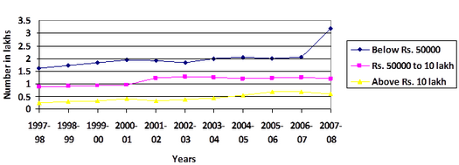

**NUMBER OF CORPORATE TAXPAYERS BY INCOME**

The tax rate is 25 percent for domestic companies. For new companies incorporated after 1 October 2019 and beginning production before 31 March 2023, the tax rate is 15 percent. Both rates apply only if a company claims no exemptions or concessions.

For foreign companies, the tax rate is 40 percent (50 percent on royalties and technical services). Surcharges and cesses, including a four-percent health-and-education cess, are levied on the flat rate. Electronic filing is mandatory.

**SURCHARGES**

Non-corporate taxpayers pay a 10-percent surcharge on income between ₹ 5 million and ₹ 10 million. There is a 15-percent surcharge on income over ₹ 10 million. Domestic companies pay seven percent on taxable income between ₹ 10 million and ₹ 100 million, and 12 percent on income over ₹ 100 million. Foreign companies pay two percent on income between ₹ 10 million and ₹ 100 million, and five percent on income over ₹ 100 million.

**PENALTIES**

Penalties can be levied under sec 271(1)(c) for concealing or misrepresenting income. Penalties may range from 100 to 300 percent of the tax evaded. Under-reporting or misreporting income is penalized under sec 270A. Penalties are 50 percent of the tax on under-reported income and 200 percent of the tax on misreported income. Late fees are payable under sec 234F.

* + 1. **INCOME TAX SLAB RATES**

In India, income tax liability is calculated on the basis of applicable slab rates. The finance minister of India outlines these slab rates. Recently, in budget 2023, the government has reduced the slab rates for taxpayers and extended the standard deduction benefit to salaried individuals and pensioners in the new tax regime.

**WHAT ARE INCOME TAX SLABS?**

Indian taxpayers are bracketed into different income categories for easier and fairer taxation. For instance, an individual making ₹5,00,000 per annum should not have to pay the same tax as someone making ₹50,00,000 per annum. The tax slab system classifies people based on their income and taxes people progressively on the higher income that they make.  
At present, India has two different income tax regimes for tax slabs. The old tax regime categorized taxpayers into three different categories with taxes ranging from 5% to 30%. In the Union Budget of 2020, the finance minister introduced new tax slabs as an alternative. Further, budget 2023 proposed some changes to the new income tax regime, and now there are six different tax slabs for taxpayers.

**INCOME TAX SLABS AS PER THE NEW AND OLD TAX REGIME**

As already outlined, the new tax regime has six different income tax slabs as compared to three under the old tax regime. The income tax new tax regime has done away with most deductions and exemptions that could be claimed under the old tax regime.  
Apart from knowing the different income tax slabs and the newly-introduced income tax slabs of 2020, one must also know that individual taxpayers in the old regime are categorized into three types:

* Residents and non-resident individuals aged below 60 years.
* Resident senior citizens aged between 60 and 80 years.
* Resident super senior citizens aged over 80 years.

The income tax slab for each of these categories of individuals also differs.

Individuals can choose between the old and new tax regimes. However, if they don’t choose any tax regime then by default the new tax regime will apply to them.

|  |  |
| --- | --- |
| Income Slabs | Income Tax Slab Rates Under the New Regime for Individuals and Hindu Undivided Families |
| Up to ₹3,00,000 | NIL |
| ₹3,00,000 – ₹6,00,000 | 5% |
| ₹6,00,000 – ₹9,00,000 | 10% |
| ₹9,00,000 – ₹12,00,000 | 15% |
| ₹12,00,000 – ₹15,00,000 | 20% |
| More than ₹15,00,000 | 30% |

**NEW TAX REGIME FOR FY 2023-24**

The tax slabs and rates are the same for all individuals and HUFs under the new regime. This means that people up to 60 years, senior citizens (60-80 years), and super senior citizens above 80 years are subject to the same income tax slabs. Apart from the above, the following re also applicable on the tax amount under the new tax regime.

* Health & education cess of 4% is applicable on the tax amount.
* Surcharge rates applicable on individuals are as follows: -

|  |  |
| --- | --- |
| Surcharge Rates – New Regime | |
| Less than ₹50 Lakh | Nil |
| Income between ₹50 Lakh – ₹1 Crore | 10% |
| Income between ₹1 Crore – ₹2 Crore | 15% |
| Income above ₹2 Crore | 25% |

**In the 2023 budget, surcharge on income above ₹5 Crore was reduced from 37% to 25%.**

**OLD TAX REGIME FOR FY 2023-24**

|  |  |  |  |
| --- | --- | --- | --- |
| Income Slabs | Income Tax Slab Rates for Individuals and HUFs Below 60 Years | Income Tax Slab Rates for Senior Citizens Aged 60-80 Years | Income Tax Slab Rates for Super Senior Citizens Over 80 Years |
| Up to ₹2,50,000 | Nil | Nil | Nil |
| ₹2,50,000 – ₹5,00,000 | 5% | 5% | Nil |
| ₹5,00,000 – ₹10,00,000 | 20% | 20% | 20% |
| Above ₹10,00,000 | 30% | 30% | 30% |

As mentioned earlier, under the old regime, taxpayers are categorized into three different types. The income tax slab rates are as follows:

Some other things to note with the old tax regime are:

* Health & education cess of 4% is applicable on the tax amount.
* Surcharge rates applicable on individuals are as follows: -

|  |  |
| --- | --- |
| Surcharge Rates – Old Regime | |
| Less than ₹50 Lakh | Nil |
| Income between ₹50 Lakh – ₹1 Crore | 10% |
| Income between ₹1 Crore – ₹2 Crore | 15% |
| Income above ₹2 Crore | 25% |

In the 2023 budget, surcharge on income above ₹5 Crore was reduced from 37% to 25%.

**INCOME TAX SLABS FOR INDIVIDUALS BELOW 60 YEARS**

|  |  |
| --- | --- |
| Income Slabs | Income Tax Slab Rates |
| Up to ₹2,50,000 | Nil |
| ₹2,50,000 – ₹5,00,000 | 5% |
| ₹5,00,000 – ₹10,00,000 | 20% |
| Above ₹10,00,000 | 30% |

**INCOME TAX SLABS FOR INDIVIDUALS AGED BETWEEN 60 AND 80 YEARS**

|  |  |
| --- | --- |
| Income Slabs | Income Tax Slab Rates |
| Up to ₹3,00,000 | Nil |
| ₹3,00,000 – ₹5,00,000 | 5% |
| ₹5,00,000 – ₹10,00,000 | 20% |
| Above ₹10,00,000 | 30% |

|  |  |
| --- | --- |
| Income Slabs | Income Tax Slab Rates |
| Up to ₹5,00,000 | Nil |
| ₹5,00,000 – ₹10,00,000 | 20% |
| Above ₹10,00,000 | 30% |

**INCOME TAX SLABS FOR INDIVIDUALS ABOVE 80 YEARS**

**2.3 AMPLIFICATION OF TAX DEDUCTION AT SOURCE**

Tax deduction at source (TDS) is an Indian withholding tax that is a means of collecting tax on income, dividends, or asset sales by requiring the payer to deduct tax due before paying the balance to the payee.

Under the Indian Income Tax Act of 1961, Income Tax must be deducted at source as per the provisions of the Income Tax Act, 1961. Any payment covered under these provisions shall be paid after deducting a prescribed percentage of income tax. It is managed by the Central Board for Direct Taxes (CBDT) and is part of the Department of Revenue managed by the Indian Revenue Service. It has great importance while conducting tax audits. Assessee is also required to file quarterly returns to Central Board of Direct Tax (CBDT). Returns state the TDS is deducted and paid to the government during the Quarter to which it relates.

**2.3.1 OBJECTIVES OF TDS**

Tax deduction at source (TDS) has come into existence with the motive of collecting tax from different sources of income. As per this concept, a person (Payer) who is responsible to make payment of specified nature to any other person (Payee) shall deduct tax at source before making payment to such person (Payee) and remit the same into the account of the Central Government. The Payee from whose TDS has been deducted would be entitled to get a credit of the amount so deducted at the time of assessment of income tax.

**2.3.2 TDS ON DIVIDENDS**

Section 302 of India's Income Tax Act 1961 by-law notes.

* Prior to the Budget 2020, dividend income was exempt from tax in the hands of the shareholder. But Since Budget 2020, any Dividend Income in excess of INR 5000 is liable for TDS @ 10% u/s 194.
* TDS provisions under this section are attracted only in respect of deemed dividend u/s 2(22)(e), If such dividend exceeds 2500 in the year.
* Rate of deduction of tax in respect of such dividend is 1%.
* Provisions will not apply to dividends receivable by SADHA, GIC (General Insurance Corporation), its subsidiaries or any other insurer provided shares are owned by it or in which it has full beneficial interest: Provided also that no such deduction shall be made in respect of any dividends referred to in section 115-O.
* Higher TDS rates for non-files of income tax returns.

**2.3.3 TDS ON IMMOVABLE PROPERTY**

**1. Section 194IA of Income Tax Act, 1961**

* This provision is applicable in respect of transactions effected on or after June 1, 2013.
* It seeks deduction of tax at source on the transfer of certain immovable property other than agricultural land to a resident transferor.
* Any person being a transferee who is liable to Pay to a resident by way of consideration for the transfer of any immovable property exceeding 50 Lakhs shall at the time of credit of such sum to the account of the transferor or at the time of payment in whatever manner, has to deduct tax at source at 1% only.

This TDS on the property is required to be deposited in 30 days from the end of the month in which deduction is made for all payments to be made on or after 1 June 2016.

**2. Section 194IB of Income Tax Act, 1961**

* This provision is applicable in respect of transactions effected on or after June 1, 2017.
* It seeks deduction of tax at source on payment of rent exceeding Rs. 50,000 in a month by an individual or HUF to a resident landlord.
* TDS shall be deducted @ 5% at the time of credit of rent for the last month of the previous year or the last month of the tenancy if the property is vacated during the year, as the case may be.
* Where tax is deducted under section 194-IB, it is required to be deposited through a challan-cum-statement in Form No. 26QC within 30 days from the last day of the month in which such tax is deducted.
* A certificate in Form No. 16C shall be issued by the deductors within 15 days from the due date of furnishing challan-cum-statement in Form No. 26QC.
* There is no requirement to apply or obtain Tax Deduction or Collection Account Number (TAN) for deducting tax under this section. Hence, a deductor can use his PAN in place of TAN.

**3. Section 194C of Income Tax Act, 1961**

* Tax needs to be deducted 1% (for individual, HUF)/ 2% (for others) of payment where payment is made for carrying out any work (including supply of labour for carrying out any work and advertisements) by a contractor/sub-contractor.
* Such work must be in pursuance of a contract (including sub-contract) between the contractor and payer.
* TDS is to be made at the time of credit to the account of the contractor or at the time of payment in cash or by cheque or draft or by any other mode whichever is earlier.
* No TDS shall be deducted if the single-time payment to the contractor does not exceed RS. 35000 or Rs. 1,00,000 in aggregate during the year.
* TDS Can be deducted when the date of actual payment of cash or the date of crediting the sum to the payee's account or the date of issue of cheque, draft, or by any other mode, whichever is earlier.
* Every affordable housing scheme gets extended for one more year till 31 March 2022.

**2.3.4 TDS CERTIFICATES AND IMPACT OF NON-COMPLIANCE TO TDS**

**TDS CERTIFICATES**

A Payer is required to issue a TDS certificate called form 16 for salaried employees and form16A for non-salaried employees within a specified time. Form 16D is a TDS Certificate issued for payment of a commission, brokerage, contractual fee, the professional fee under section 194M by the payer. Under Section 194M if the payments to resident contractors and professionals exceed INR 50,00,000 during the Financial Year, the payer has to deduct tax at the rate of 5% from the sum payable to a resident payee.

Payer has to issue TDS Certificates within two months of the next financial year.

**There are two types of major forms under TDS namely:**

**Form 16**

Form 16 is a certificate where the employer declares details about the salary an employee earned during the year and details of deducted TDS. Form 16 has two parts Part A and Part B. Part A consists of employer and employee details, which include name, address, PAN, TAN details, employment period, and details of TDS deducted & deposited with the government. Part B includes salary, income, deductions, and tax payable details, etc.

**Form 16A**

Form 16A is also a TDS Certificate but it is applicable for TDS on Income other than Salary. This certificate features details such as the name and address of the payer or payee, PAN/TAN details, challan details of TDS deposited, income, and TDS deducted and deposited on such income. Details from Form 16A will be fetched on Form 26AS.

Form 26AS can also be used to verify the TDS deduction. Form 26AS is a statement that provides details of any amount deducted as TDS or TCS from various sources of income of a taxpayer. You can view Form 26AS through the TRACES portal.

**IMPACT OF NON-COMPLIANCE TO TDS**

Income Tax Act, 1961

* Disallowance u/s. 40(a) (ia) of Income Tax Act, 1962 (Act).
* Raising of demand u/s. 201(1) of the Act.
* Charging of Interest u/s (1A) of the Act.
* Levying penalty u/s. 271C of the Act.

**Income tax is also paid by Tax Deduction at Source (TDS):**

|  |  |  |  |
| --- | --- | --- | --- |
| **Section** | **Payment** | **TDS threshold** | **TDS** |
| 192 | Salary | Exemption limit | As specified in Part III of I Schedule |
| 193 | Interest on securities | Subject to provisions | 10% |
| 194A | Other interest | Banks – ₹10,000 (under age 60); ₹ 50,000 (over 60). All other interest – ₹5,000 | 10% |
| 194B | Lottery winnings | ₹10,000 | 30% |
| 194BB | Horse-racing winnings | ₹10,000 | 30% |
| 194C | Payment to resident contractors | ₹30,000 (single contract); ₹100,000 (multiple contracts) | 2% (companies); 1% otherwise |
| 194D | Insurance commission | ₹15,000 | 5% (individual), 10% (domestic companies) |
| 194DA | Life-insurance payment | ₹100,000 | 1% |
| 194E | Payment to non-resident sportsmen or sports association | Not applicable | 20% |
| 194EE | Payment of deposit under National Savings Scheme | ₹2,500 | 10% |
| 194F | Repurchase of unit by Mutual Fund or Unit Trust of India | Not applicable | 20% |
| 194G | Commission on sale of lottery tickets | ₹15,000 | 5% |
| 194H | Brokerage commission | ₹15,000 | 5% |
| 194-I | Rents | ₹180,000 | 2% (plant, machinery, equipment), 10% (land, building, furniture) |
| 194IA | Purchase of immovable property | ₹5,000,000 | 1% |
| 194IB | Rent by individual or HUF not liable to tax audit | ₹50,000 | 5% |
| 194J | Professional or technical services, royalties | ₹30,000 | 10% |
| 194LA | Compensation on acquisition of certain immovable property | ₹250,000 | 10% |
| 194LB | Interest paid by Infrastructure Development Fund under section 10(47) to non-resident or foreign company | – | 5% |
| 194LC | Interest paid by Indian company or business trust on money borrowed in foreign currency under a loan agreement or long-term bonds | – | 5% |
| 195 | Interest or other amounts paid to non-residents or a foreign company (except under §115O) | As computed by assessing officer on application under §195(2) or 195(3) | Avoiding double taxation |

**2.4 AMPLIFICATION OF VALUE ADDED TAX (VAT)**

A value-added tax (VAT), known in some countries as a goods and services tax (GST), is a type of tax that is assessed incrementally. It is levied on the price of a product or service at each stage of production, distribution, or sale to the end consumer. If the ultimate consumer is a business that collects and pays to the government VAT on its products or services, it can reclaim the tax paid. It is similar to, and is often compared with, a sales tax. VAT is an indirect tax because the person who ultimately bears the burden of the tax is not necessarily the same person as the one who pays the tax to the tax authorities.

The amount of VAT is decided by the state as a percentage of the price of the goods or services provided. As its name suggests, value-added tax is designed to tax only the value added by a business on top of the services and goods it can purchase from the market.



**A BELGIAN VAT RECEIPTS**

To understand what this means, consider a production process where products get successively more valuable at each stage of the process. Each VAT-registered company in the chain will charge VAT as a percentage of the selling price, and will reclaim the VAT paid to purchase relevant products and services, the effect is that net VAT is paid on the value added. When an end-consumer makes a purchase subject to VATwhich is not in this case refundablethey are paying VAT for the entire production process, since VAT is always included in the prices.

The VAT collected by the state from each company is the difference between the VAT on sales and the VAT on purchase of goods and services upon which the product depends,that is the net value added by the company.

**VAT REFUNDS**

Many countries offer VAT refunds to international travellers, both individual and business travellers. While VAT refunds are commonly utilized by tourists, the process for business travellers to reclaim VAT can be more complex. As a result, eligible refunds for business travel are often left unclaimed.

Some countries, particularly in Western Europe, offer VAT refunds on business-related expenses to encourage the hosting of business meetings, events, and conferences within their borders. These refunds often extend to costs incurred during trade fairs and exhibitions. In certain countries, VAT paid on meals and fuel may also be eligible for a refund.

**2.4.1 COMPARISON OF VAT WITH INCOME TAX AND SALES TAX**

**COMPARISON WITH INCOME TAX**

Like an income tax, VAT is based on the increase in value of a product or service at each stage of production or distribution. However, there are some important differences:

* A VAT is usually collected by the end retailer. Therefore, even though VAT is actually incurred by all stages of production and distribution, it is frequently compared to a sales tax.
* A VAT is usually a flat tax.
* For VAT purposes, an importer is assumed to have contributed 100% of the value of a product imported from outside of the VAT zone. The importer incurs VAT on the entire value of the product, and this cannot be refunded, even if the foreign manufacturer paid other forms of income tax. This is in contrast to the US income tax system, which allows businesses to expense costs paid to foreign manufacturers. For this reason, VAT is often considered by US manufacturers to be a trade barrier.

**COMPARISON WITH SALES TAX**

Value-added tax avoids the cascade effect of sales tax by taxing only the value added at each stage of production. For this reason, throughout the world, VAT has been gaining favour over traditional sales taxes. In principle, VAT applies to all provisions of goods and services. VAT is assessed and collected on the value of goods or services that have been provided every time there is a transaction of saleor purchase. The seller charges VAT to the buyer, and the seller pays this VAT to the government. If, however, the purchasers are not the end users, but the goods or services purchased are costs to their business, the tax they have paid for such purchases can be deducted from the tax they charge to their customers. The government receives only the difference, in other words, it is paid tax on the gross margin of each transaction, by each participant in the sales chain.

A sales tax incentivizes vertical integration and therefore discourages specialisation and trade due to the fact that it taxes the full value of the product at each stage of production, instead of only the value that has been added to the product.

In many developing countries such as India, sales tax or VAT are key revenue sources as high unemployment and low per capita income render other income sources inadequate. However, there is strong opposition to this by many sub-national governments as it leads to an overall reduction in the revenue they collect as well as of some autonomy.

A general economic idea is that if sales taxes are high enough, people start engaging in widespread tax evading activity. On the other hand, total VAT rates can rise above 10% without widespread evasion because of its collection mechanism. However, because of its particular mechanism of collection, VAT is targeted by specific frauds like carousel fraud, which can be very expensive in terms of loss of tax incomes for states.

**2.4.2 EXAMPLES**

**WITHOUT ANY TAX**

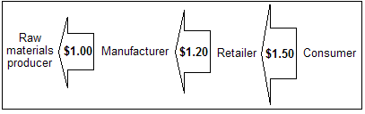

* A widget manufacturer, for example, spends $1.00 on raw materials and uses them to make a widget.
* The widget is sold wholesale to a widget retailer for $1.20, leaving a gross margin of $0.20.
* The widget retailer then sells the widget to a widget consumer for $1.50, leaving a gross margin of $0.30.

**WITH A SALES TAX**

With a 10% sales tax:

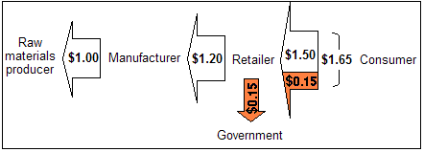

* The manufacturer spends $1.00 for the raw materials, certifying it is not a final consumer.
* The manufacturer charges the retailer $1.20, checking that the retailer is not a consumer, leaving the same gross margin of $0.20.
* The retailer charges the consumer ($1.50 × 1.10) = $1.65 and pays the government $0.15, leaving the gross margin of $0.30.

So, the consumer has paid 10% ($0.15) extra, compared to the no taxation scheme, and the government has collected this amount in taxation. The retailers have not paid any tax directly (it is the consumer who has paid the tax), but the retailer has to do the paperwork in order to correctly pass on to the government the sales tax it has collected. Suppliers and manufacturers have the administrative burden of supplying correct state exemption certifications which the retailer must verify and maintain.

The manufacturer is also responsible for making sure that their customers (retailers) are only intermediates and not end consumers (otherwise the manufacturer itself would need to charge the tax). In addition, the retailer must keep track of what is taxable and what is not along with the various tax rates in each of the cities, counties and states for the 35,000+ global taxing jurisdictions.

**WITH A VALUE-ADDED TAX**

[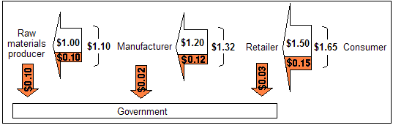](https://en.wikipedia.org/wiki/File:VAT3b22.png)With a 10% VAT:

* The manufacturer spends ($1 × 1.10) = $1.10 for the raw materials, and the seller of the raw materials pays the government $0.10.
* The manufacturer charges the retailer ($1.20 × 1.10) = $1.32 and pays the government ($0.12 *minus* $0.10) = $0.02, leaving the same gross margin of ($1.32 – $1.10 – $0.02) = $0.20.
* The retailer charges the consumer ($1.50 × 1.10) = $1.65 and pays the government ($0.15 *minus* $0.12) = $0.03, leaving the same gross margin of ($1.65 – $1.32 – $0.03) = $0.30.
* The manufacturer and retailer realize less gross margin from a percentage perspective. If the cost of raw material production were shown, this would also be true of the raw material supplier's gross margin on a percentage basis.
* Note that the taxes paid by both the manufacturer and the retailer to the government are 10% of the *values added* by their respective business practices (e.g. the *value added* by the manufacturer is $1.20 minus $1.00, thus the tax payable by the manufacturer is ($1.20 – $1.00) × 10% = $0.02).

In the VAT example above, the consumer has paid, and the government received, the same dollar amount as with a sales tax. At each stage of the production, the seller collects a tax on behalf of the government and the buyer pays for the tax by paying a higher price. The buyer can then be reimbursed for paying the tax, but only by successfully selling the value-added product to the buyer or consumer in the next stage. In the previously shown examples, if the retailer fails to sell some of its inventory, it suffers a greater financial loss in the VAT scheme, in comparison to the sales tax regulatory system, by having paid a higher wholesale price on the product it wants to sell.

Each business is responsible for handling the necessary paperwork in order to pass on to the government the VAT it collected on its gross margin. The businesses are freed from any obligation to request certifications from purchasers who are not end users, and of providing such certifications to their suppliers, but they incur increased accounting costs for collecting the tax, which are not reimbursed by the taxing authority. For example, wholesale companies now have to hire staff and accountants to handle the VAT paperwork, which would not be required if they were collecting sales tax instead.

**CHAPTER III**

**RESEARCH METHODOLOGY**

**AND**

**DATA COLLECTION**

**3.1 RESEARCH OBJECTIVES OF THE STUDY**

To examine the necessity of conducting the audits for the clients, why it is a requisite forthe firms to get the Audits done of their financial accounts and the timely filing of thetaxes levied on them.For examining whether the services provided by the CA firms are satisfactory and theactivities are conducted while maintaining the authenticity and confidentiality for theclient companies or not.To learn about what is taxation and auditing, how they are made mandatory and why it isnecessary for companies, individuals to pay taxes.

**3.2 RESEARCH METHODOLOGY ADOPTED**

The study is based on analytical method. The primary data is collected by personalcollection of the book of accounts of the mentioned clients and thereby conducting thetax audit, along with interviewing the staff for knowing the views, comments andconfidence regarding the performance of audit, taxation and consultancy services given by the CA firms.

The primary data is collected by interviewing the internal staff of the client companies.The secondary data is collected from the books and websites.

**3.2.1 RESEARCH DESIGN**

The research design is of Descriptive type since it involved in studying the in-depthanalysis of the data of the clients and only after analysing the task of performing thetax audit on the financial statements provided by the clients would be performed.

**3.3 METHOD OF DATA COLLECTION**

**DATA SOURCE**

The data required for conducting of the study was collected from the primary sourcesof data, namely, from the account’s office of the clients while conducting the tax audit function. Also, for performing thetallying function of the Sales tax figures, for the matching of the figures, the data wasalso gathered from the Income tax department websites, the website of Sales tax,VAT/DVAT/CST etc.

**Primary Sources:**Client’s Companies Accounts Office.

**Secondary data:**Registrar of Companies, Income Tax Department, Sales tax,VAT/DVAT/CST websites etc.

**3.4 ANALYSIS TECHNIQUE**

The data collected from the office was analysed using accounting methods and techniques. Findings are made on the basis of analysis of the data gathered from the primary and secondary sources. Recommendations are mad on the basis of findings drawn from various data collected and also based on the observations for the areas where corrections can be made.

**3.5 DATA ANALYSIS**

**Name: SRIHARSHATHANAIAH**

|  |  |  |  |  |
| --- | --- | --- | --- | --- |
|  | Sch. No | TDS  deducted | TDS  claimed | Gross  Salary |
| Income from Salaries  Employer-1: INSPECTOR OF EXICSE  Salary: as per Form 16 / Certificate  Standard deduction u/s 16(ia)  Less: Tax on employment u/s 16(iii)  Income chargeable under the head “Salaries” | 1  2  3 | 50,000  2,400 | 7,28,203  52,400 | 6,75,803 |
| Income from other sources  Interest Income | 4 |  |  | 5,776 |
| Gross Total Income  Deductions under Chapter VI-A  80TTA: Interest on Savings a/c  Investment u/s 80C, CCC, CCD  PF contribution  Life Insurance premium  Deduction subject to ceiling u/s 80CCE |  | 2,40,000  81,984 | 5,776  1,50,000 | 6,81,579  1,55,776 |
| Total Income  Total income rounded off u/s 288A  Tax on total income  Add: Cess  Tax with cess  TDS / TCS  Balance tax payable | 5 | 6 |  | 5,25,803  5,25,800  17,660  706  18,366  18,367  0 |

**Statement of Income**

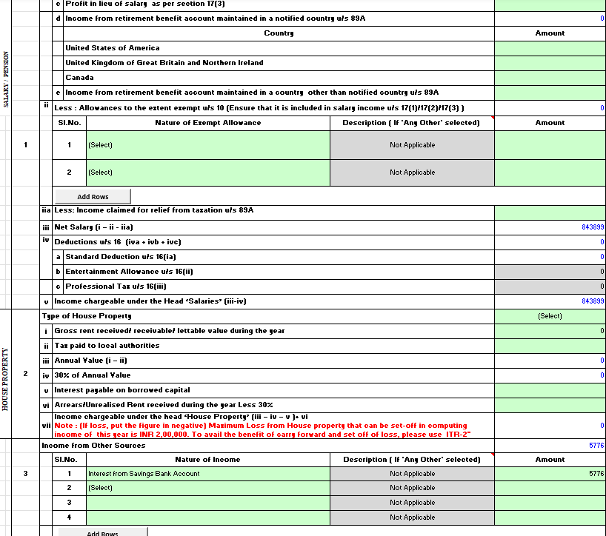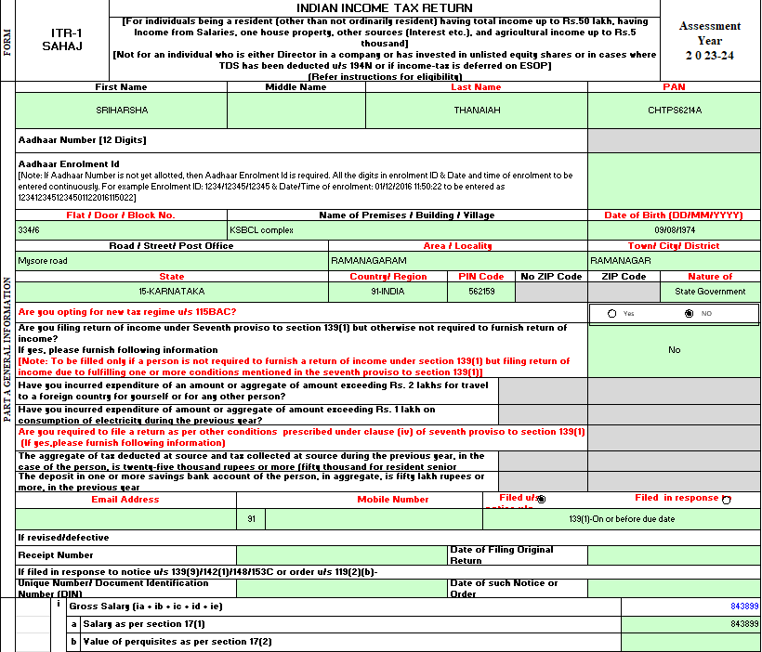

**Name: AISHWARYA MANKARE**



|  |  |  |  |  |
| --- | --- | --- | --- | --- |
|  | Sch. No | TDS deducted | TDS claimed | Gross Salary |
| Income from House Property  Let-out properties  Property- 1: NH-9, Tenant – Bharat Tyres  Gross annual value  Less: Municipal Taxes  Less: Standard deduction u/s 24(a)  Income chargeable under the head “House Property” | 1  2 |  | 2,00,000  0  60,000 | 1,40,000 |
| Profession: u/s 44ADA – Presumptive profits  Income chargeable under the head “Business and Profession” | 3 |  | 8,56,713 | 8,56,713 |
| Income from other sources  Interest Income | 4 |  |  | 32,901 |
| Gross Total Income  Deduction under Chapter VI-A  80TTA: Interest on Savings a/c  Investment u/s 80C, CCC, CCD  Life insurance premium  Deduction subject to ceiling u/s 80CCE | 5 | 2,25,131 | 6,479  1,50,000 | 10,29,614  1,56,479 |
| Total Income  Total income rounded off u/s 288A  Tax on Total Income  Add: Cess  Tax with Cess  TDS / TCS  Refund Due | 6  7 |  |  | 8,73,140  8,73,135  87,128  3,485  90,613  90,800  190 |

**Statement of Income**

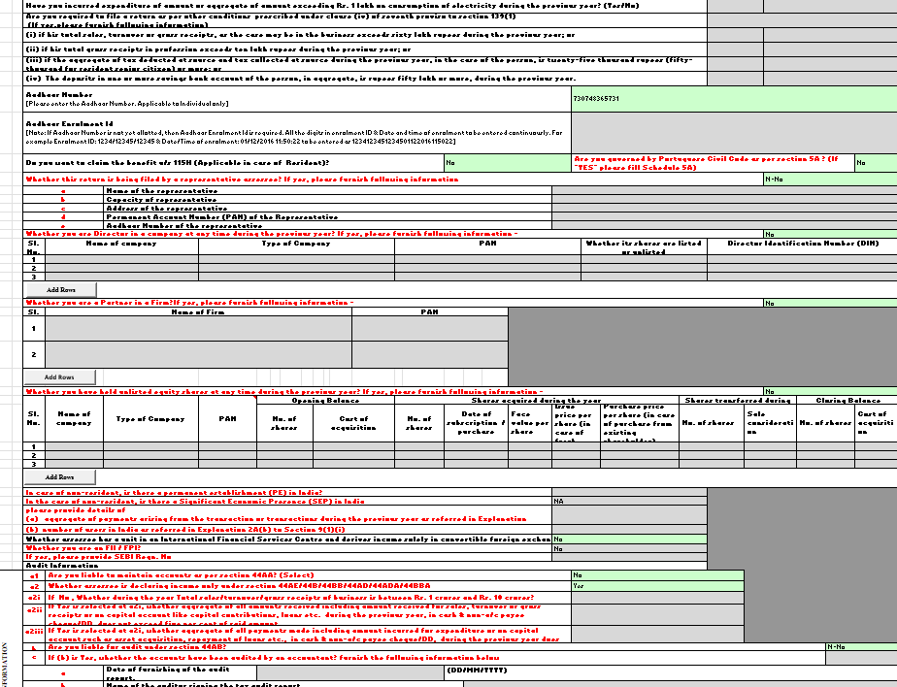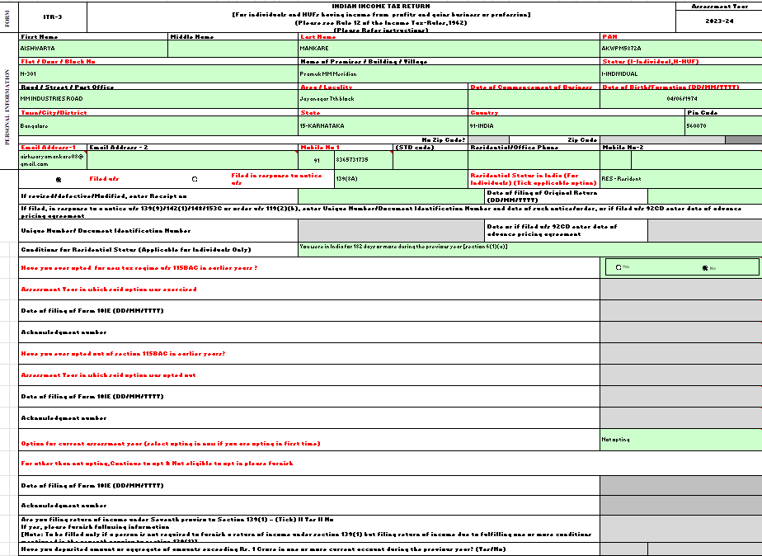



**Name: DINESH JAVER BHAI PATEL**

**Statement of Income**

|  |  |  |  |  |
| --- | --- | --- | --- | --- |
|  | Sch. No | TDS deducted | TDS claimed | Gross Salary |
| Profits and gains of Business or Profession  Business: Presumptive Profits u/s 44AD  Income from partnership firm SHIVASHAKTI TIMBER AND PLYWOOD  Income chargeable under the head “Business and Profession” | 1  2 |  | 5,05,000  0 | 5,05,000 |
| Income from other sources  Interest Income | 3 |  |  | 5,251 |
| Gross Total Income  Deductions under Chapter VI-A  80TTA: Interest on Savings a/c |  |  |  | 5,10,251  5,251 |
| Total Income  Tax on total income  Add: Cess  Tax with cess  Interest u/s 234B  Interest u/s 234C  Net tax payable  Self-assessment tax paid  Balance tax payable | 4 |  | 980  140 | 5,05,000  13,500  540  14,040  1,120  15,160  15,160  0 |

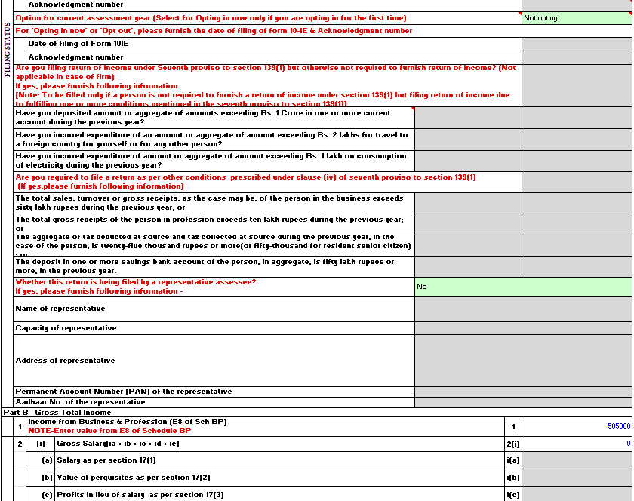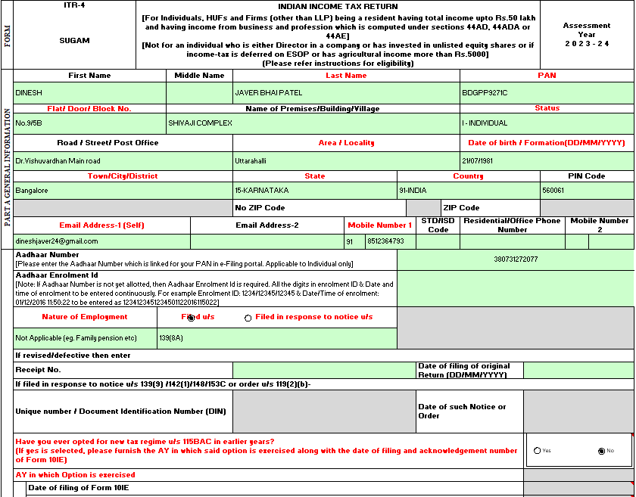

**CHAPTER IV**

**CONCLUSION**

The primary goal of this project report was to identify the need and the requirement fora company to conduct tax audits. It showed that unless and until the companiesconducts of their accounts how will the assessor be able to ensure that the figures andthedata mentioned in the financial statements by the companies are actual.

Audit of accounts in the corporate sector was always mandatory by virtue of the provisionsof The Companies Act, 1956. Realizing the importance of audit this requirement has beenextended to non-corporate assesses. Since by virtue of sec 44AB all assesses irrespective oftheir nature, if they fulfil the criteria as laid out in the section have to get their accountsaudited.The intention of bringing in this piece of legislation as observed by the finance ministerwhile presenting the Union Budget for 1984-85 is the compulsory audit is intended toensure proper maintenance of books of accounts and other records, in order to reflect thetrue income of the tax payer and to facilitate the administration of tax laws by a proper presentation of the accounts before the tax authorities. This would also save the time of theAssessing Officers considerably in carrying out the verification.

The project study conducted helped in examining the areas which are of upmostimportance to be considered while preparation of the audit report. The in-depth analysisof the particular client’s financial statementshelped in analysing their growth, performance and any abnormal losses occurrence.The project also discussed about how chartered accountants’ firms conducts tax audit ofthe client’s companies’ accountswhich is statutory in nature and what are the varioustypes of advanced auditing which companies can incorporate so that their growth, performance is increased. Also, while gathering the information it was observed thatthe clients of the APAR & CO LLP are loyal and there is highcustomer satisfaction meaning that these companies come to the APAR & CO LLP since they offer best services thereby maintaining the ethicsof the advisory. Hence, this study could be concluded with the mentioning of there is aliability for the assessee irrespective of their taxable income of Tax Audit.

**4.1 SUMMARY**

I decided to do my internship in a CA firm, named APAR & CO LLP. In the firm, I worked under the control of a professional chartered accountant.As I want to pursue my carrier in similar field, during this internshipworking in CA firm for my internship period was an excellent choice. Working in APAR & CO LLP I got to explore how a CA firm operates and got to understand firm's organizational structure, its service offerings, and the day-to-day tasks. I got a chance to make a good connection with certified CA. I got an opportunity to grab valuable insight and develop skills while working with certified CA which would help me in my future carrier.

This three-weeks of internship program helped me identify my strengths and weaknesses, as well as areas that I need to work on to improve my skills and knowledge. Overall, this internship was an excellent way, for me to gain practical experience, develop new skills, and build connections with professionals.

**4.2 EVALUATION OF THE WORK EXPERIENCE**

This 16-week internship program has been very productive and beneficial for me. Working at APAR & CO LLP, has broaden my accounting knowledge. I got a chance to learn new accounting terms and concept while working with certified CA. Along with that, I got an opportunity to flourish my confidence. These skills will be important in my future career as a professional in the accounting field. It taught me to maintain a balance between professional world and personal world.

I got to experience the culture and accounting standards followed in those sectors. This internship program gave me a broader perspective and helped me adapt to different situations in the future.

This internship has taught me about how the professional world work and how one could survive in this world. I believe that this internship has helped me grow as a person by teaching me new things. The skills and knowledge that I gained from working in APAR & CO LLP, has contributed to my personal and career growth. Overall, this internship has been a successful and rewarding experience.

**4.3 RECOMMENDATIONS TO APAR & CO LLP**

Some recommendations that I would like to suggest to APAR & CO LLP are mention below:

* **Provide Training Program**

Training programs and seminars provide opportunities for staff and article ship to enhance their knowledge and skills in specific areas of accounting. This helps them stay updated with the latest accounting standards, regulations, and industry best practices. Conducting training programs and workshops on accounting standards and accounting law helps ensure that the firm's personnel are well versed in the applicable regulations and requirements. This knowledge is essential for accurate financial reporting, compliance with legal obligations, and maintaining the firm's reputation for professionalism andintegrity. When staffs are equipped with up-to-date knowledge and skills, they can perform their tasks more effectively and efficiently, leading to improved client service and overall operational excellence. By prioritizing ongoing training and professional development, the firm can foster a culture of continuous learning, growth, and excellence.

* **Conducting performance evaluation**

I suggest the firm to conduct performance evaluation of staff and article ship. Performance evaluation would help the staff and article ship know their weakness and strength. Throughtimely performance evaluation, staff can gain a clear understanding of their areas of expertise and areas where improvement is required. This helps them to focus on enhancing their strengths and addressing their weaknesses. Performance evaluations facilitate open and constructive feedback between managers and staff. It allows for ongoing improvement and development.

* The infrastructure and working condition reviews can improve the working efficiency of the trainees. Audit and Assurance is the tough job. Some motivational meetings and mentoring exercises would bring good feel among employees for their work. Time to time financial bonuses or performance incentives will energize the staff.
* Firm also lacks in marketing perspective as it does notmarket or introduce their business, firm is getting business only on personal relations of the partners and other firm personnel. So if firm thinks to improve its business volume it needs professional marketer as many other big firms adopted and have complete marketing department.

**4.4 LIMITATIONS**

* They have a small staff with skills base in many areas.
* Less number of staff members.
* Change in government policies and procedures may act as threat for company.
* APAR & CO LLP has many competitors. Under certain circumstances these competitors may act as a major threat for the organisation.

APAR & CO LLP is overall one of the profits making and reputed firm of Bengaluru. The organisational since its very first day is devoted to providing quality services. The detailed and through review of work and clients’ trust shows the perfection with which it is working.

The firm has earned a distinction of being placed in the category ‘A’ in the list of panels of auditors. Moreover, only these “A” category firms can audit of listed companies.

The Institute of Chartered Accountants of India has also carried out the quality control review and has issued satisfactory QCR report stating that the firm has conducted the audits of the clients in accordance with International Standards on Auditing.

**4.5 BENEFITS OF INTERNSHIP FOR STUDENTS**

**BENEFITS OF INTERNSHIP FOR EMPLOYERS**

Internships help employers by letting them evaluate potential hires, bringing in new viewpoints, and building a talent pool for future needs. It's a win-win for both employers and emerging professionals. Here are the main benefits of internships for employers:

**1. Get Extra Help**

Interns can boost your team. Whether you need someone for a specific task or a versatile helper, interns are keen to gain experience and tackle new challenges. They're eager to dive into projects and pick up skills that prepare them for their future careers.

**2. Shape Tomorrow's Team**

Internships to create a pool of potential employees. Employers often bring in interns, allowing them to train and test potential hires on a part-time basis. It's a smooth transition for students securing jobs right after college since employers are familiar with their skills and know where they fit in.

**3. Forge Lasting Connections**

You could be a lasting professional contact for your intern. Even if they don't stay on after the internship, they might have opportunities or needs in their future workplace that could benefit from collaborating with your company.

Internships bring forth advantages for students. They provide real-world exposure while enabling individuals to develop skills and forge professional connections. Internships play a role in helping students discover career options and make well-informed choices about their future. In general, internships are a part of education and have significant advantages for students in terms of academic growth and professional development.

**REFERENCE**

[**www.google.co.in**](http://www.google.co.in)

[**www.incometax.gov.in**](http://www.incometax.gov.in)